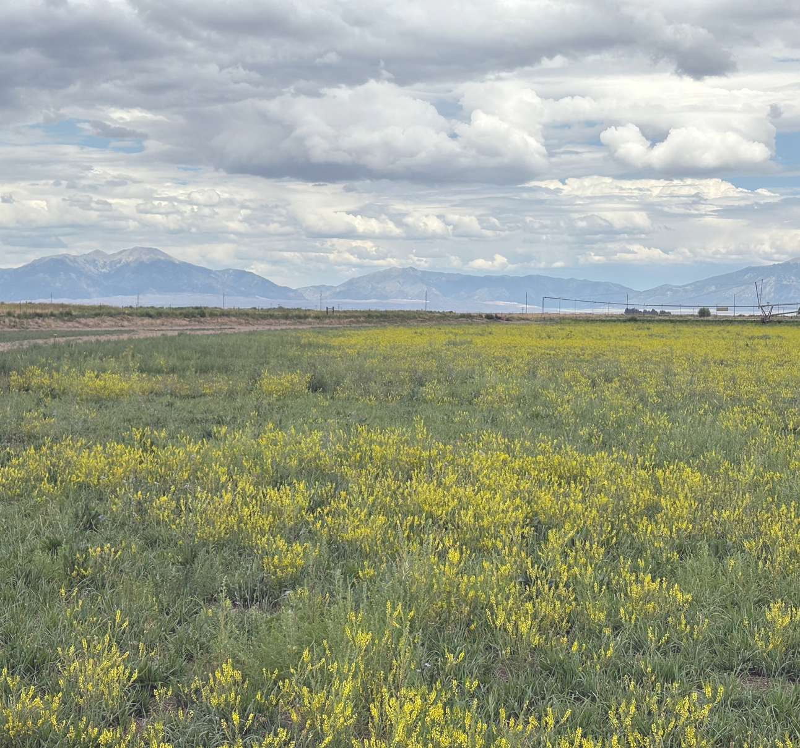
Mosca-Hooper Conservation District Annual Report

2025

Website: https://mhcd.colorado.gov/ Address: 101 S. Craft Dr. Alamosa, CO 81101 Telephone: 719-992-3661
Email: moscahoopercd1@gmail.com

MISSION STATEMENT
To provide leadership in natural resource management for the betterment of all present and future residents of the district through education and example.

DESCRIPTION
Established on June 7th, 1943, the Mosca-Hooper Conservation District (MHCD) includes the vast majority of Alamosa County.
Total acreage within the District is 462,000 acres.
317,000 acres are privately held and 145,000 acres are publicly held.
The District has a conservation history of 75+ years.

SUPERVISORS & STAFF
Bill Brinton, President Brian Roberts, Vice President
Trudi Kretsinger, Treasurer Patrick O’Neill, Secretary Derek Heersink, Supervisor
Larry Brown, Ex Officio Supervisor, CSU Extension SLV Area Director Marta Petermann, District Manager
Wayne Schwab, District Conservation Technician Kelsey Weeks, District Conservation Assistant Austin Licano, District Conservation Assistant
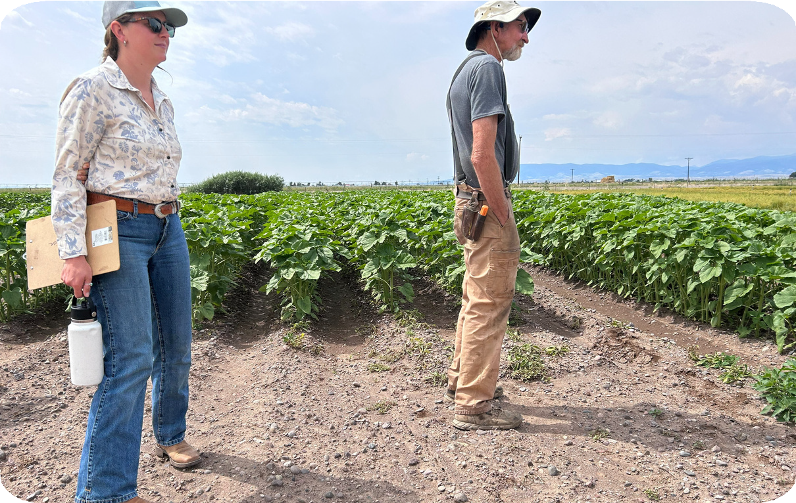
Madeline Wilson and Rob Jones view the alternative crops grown at the CSU research farm in 2025.

Colorado Soil Health Program

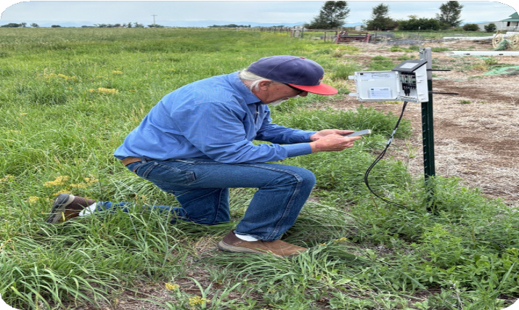
District Conservation Technician Wayne Schwab checks on a soil moisture meter at the Clark’s ranch.

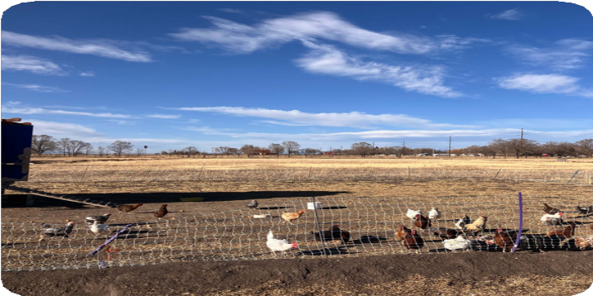
Rotational grazing, fall 2025.
The Colorado Soil Health Program ( CSHP) of the Colorado Department of Agriculture ( CDA) provided funds
to Mosca- Hooper Conservation District ( MHCD) in support of
farmers and ranchers who implement new practices such as novel crop
rotations, cover cropping, prescribed grazing, compost applications and
reduced tillage. These practices can help build healthy soil, prevent
erosion, conserve water, sequester carbon and improve productivity.
For 2025 , MHCD enrolled 12 farmers and ranchers in the CSHP.

Through the STAR Plus and Colorado Soil Health Programs, MHCD
expended $78, 800 in matching grant support to farmers and ranchers who implemented new soil health
practices.

Bringing Farmers Together
Implementing a Peer- to- Peer Learning Network in the San Luis Valley

Bringing Farmers Together began in January 2024 with the goal of creating and facilitating a collaborative learning network of agricultural producers to develop ideas and implement methods to increase soil water holding capacity and improve irrigation efficiency. In 2025, MHCD was awarded a grant with CSCB to continue this project and enlisted the help of four Host Producers/Ranchers to host 8 small group sessions with their neighbors and peers. These small groups shared their ideas and projects with one another while discussing water and soil conservation in the Valley.
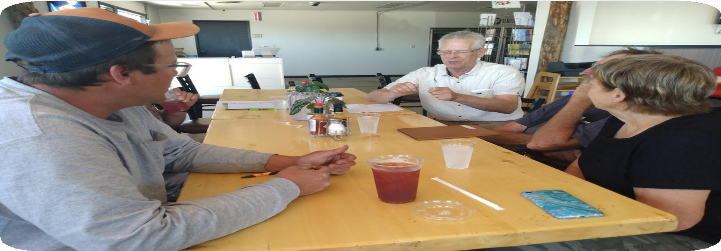
“Bringing Farmers Together” A peer learning circle of primarily potato growers at a local cafe, July 2025

Bringing Farmers Together Field Day
In addition to the small group sessions, MHCD planned, marketed, and hosted a peer-to-peer Field Day on July 19, 2025. The Field Day featured conversations and field demonstrations at four farms/ranches. Thirty-five participants, including producers/ranchers, area Partners and teachers, and community members, attended the Field Day.
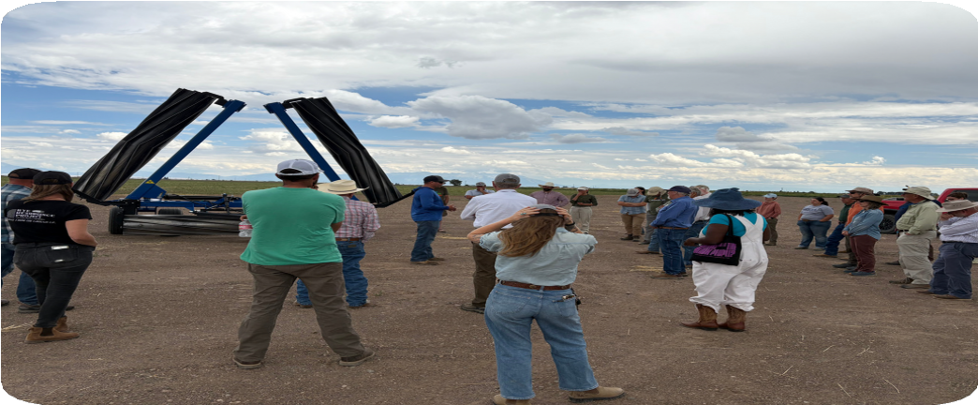
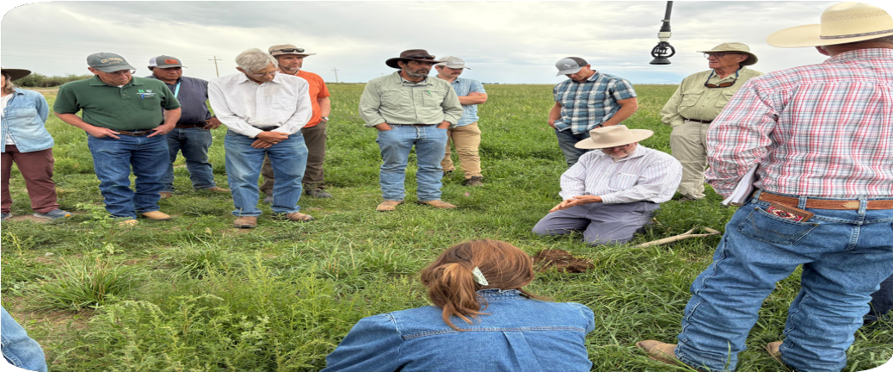

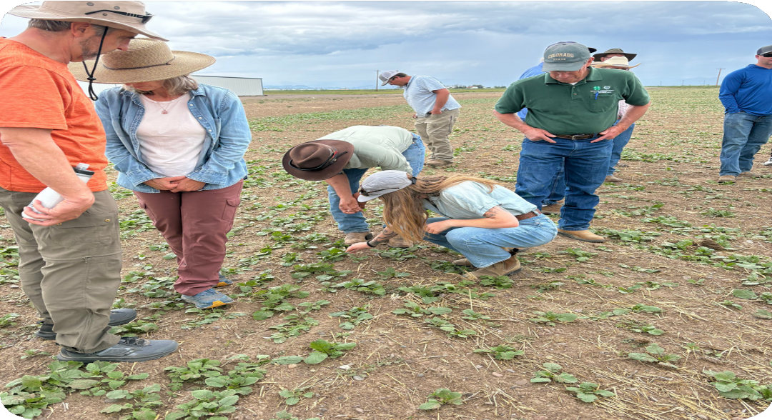
Photos on the top left and bottom left were taken at Producer Jeff McCullough’s field. Jeff talks with the group about using crimped rye in a potato rotation
Top right photo taken at Pete & Leah Clark’s ranch. Patrick O”Neill speaks with the group on how the
5 principles of soil health were being applied in this operation, initiating further conversation on water and soil conservation.

Bottom right photo: Producer Lance Curtis shares with the group his cover crop practices.

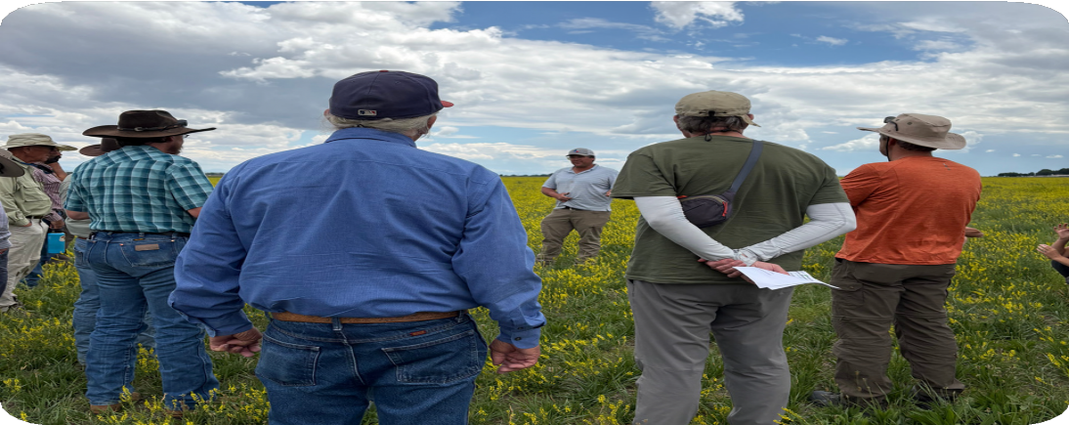

Learning about the OpenET tool during the Field Day
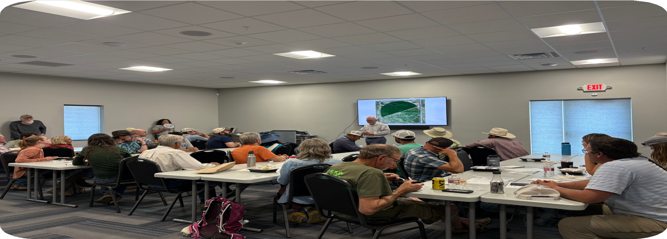
Patrick O'Neill, Agricultural Technical Advisor, gave a demonstration of the online OpenET tool, using a field that was part of the tour, as a resource for monitoring and decision-making related to plant water use.

National Wind Erosion Monitoring Network
MHCD is committed to reducing soil wind erosion in Alamosa County.
In 2024, the National Wind Erosion Research Network (NWERN) contacted MHCD to request assistance in staffing the NWERN weather station near San Luis Lakes.
A stipend from the Wright-Ingraham Institute provided initial support for the MHCD District Conservation Technician to maintain, and collect data from, the SLV site.
Funding from the CSCB Supplemental Grant has provided additional funds for MHCD to continue their work in 2025.
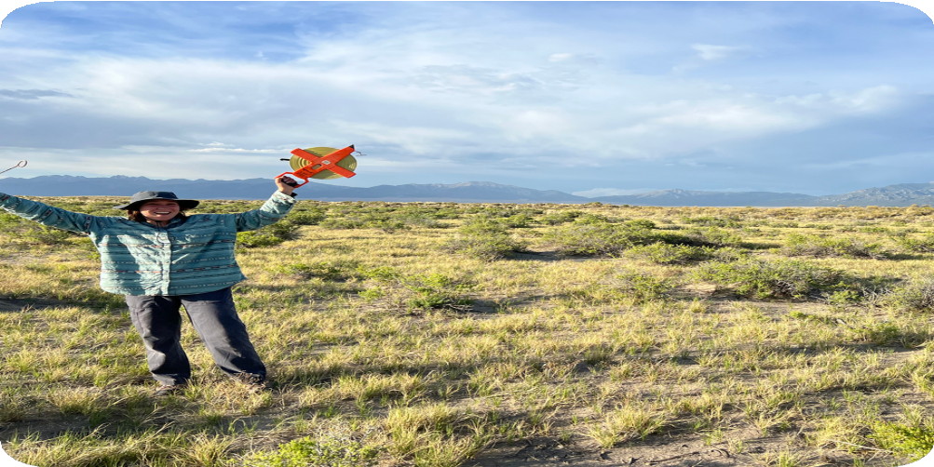
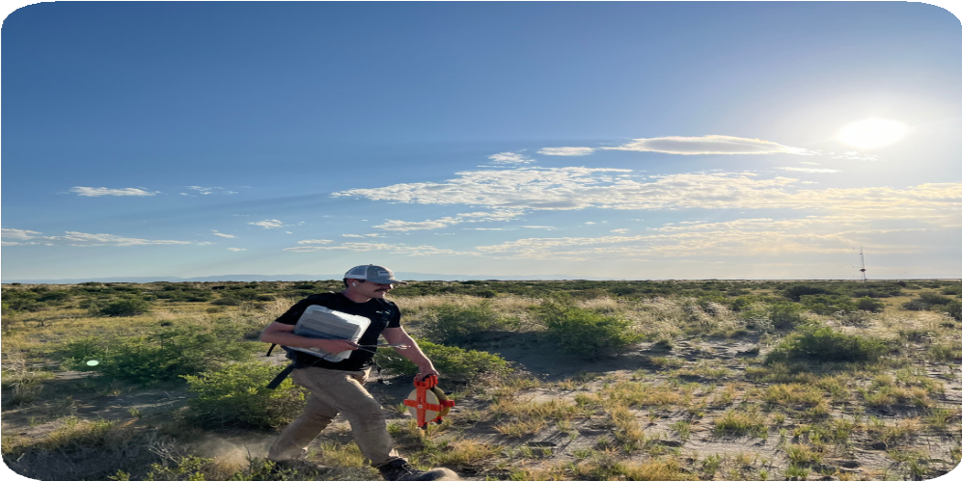
Summer Interns Rebecca (top left photo) and Jackson (top right photo) performing vegetation transects at the National Wind Erosion Research Network SLV Site.
Bottom right photo: DCT Wayne Schwab collects a sample at the site.
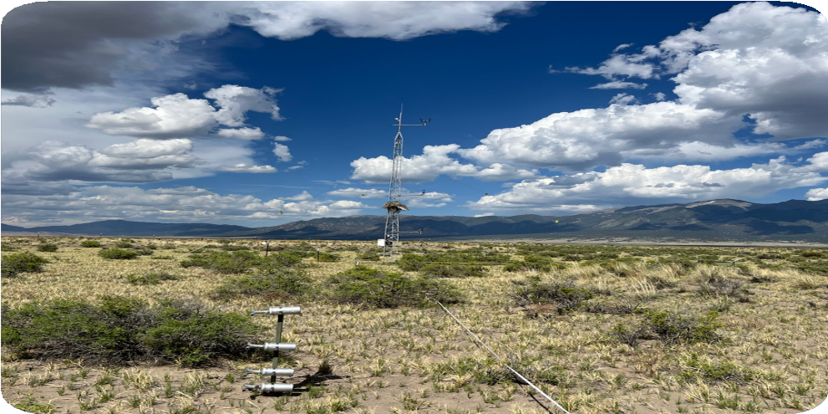
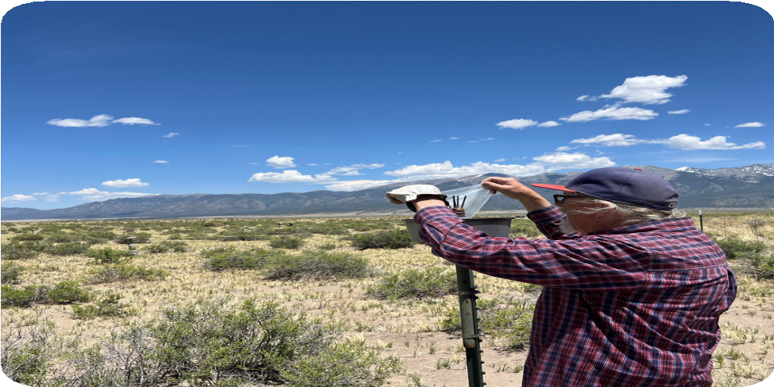

Summary of MHCD Projects and Support of Conservation Education

- Sponsored RGWCEI youth conservation programs at San Luis Valley area schools.
- Provided compost extract equipment rentals for local producers.
- Sponsored three competitive awards for projects related to soil health/soil conservation at the 2025 SLV Regional Science Fair in Alamosa.
- Provided scholarships for 2 students to attend conservation camp at Beaver Creek.
- Provided plaques for the top contenders of the 2025 SLV FFA Range Judging Contest.
- Board President Bill Brinton presented at the Ag Conference in Monte Vista about the Colorado Soil Health Program.
- Approved a 3-year (long term) operations plan which includes a new initiative for rural mental health and suicide prevention.
- Continued support of COMET training and the Coffee Break Project in the SLV.
- Hosted Agrarian Consultant Ivy Reynolds at Rio Grande Watershed Meeting to learn about her ideas regarding CREP in the San Luis Valley.

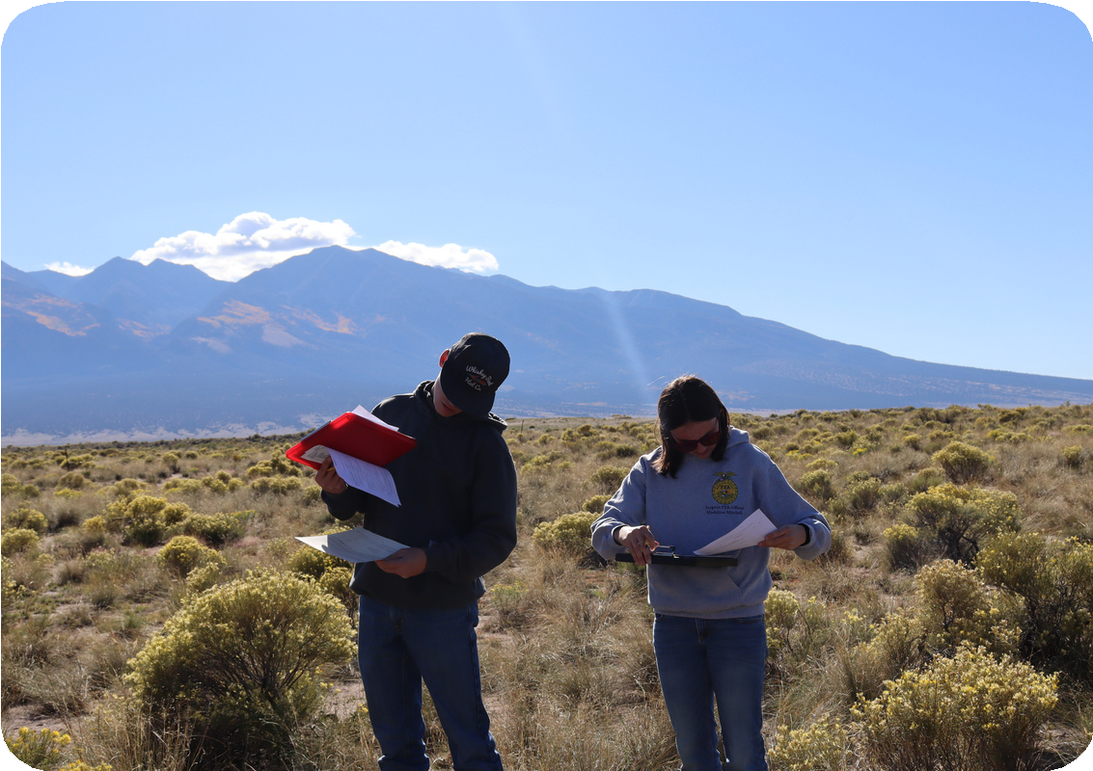
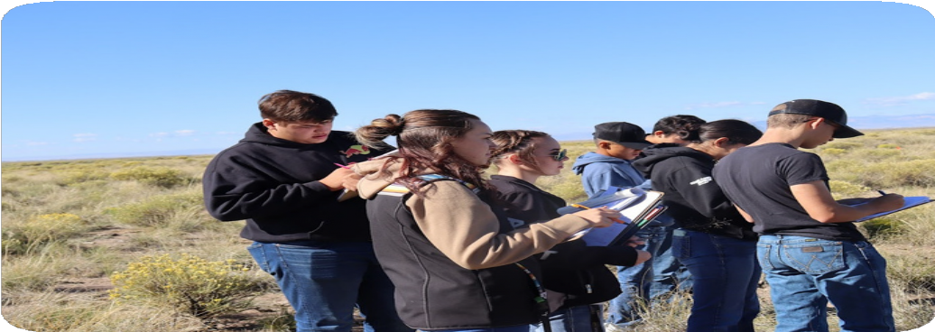

41 agriculture students, representing five FFA chapters in the region, participated in the SLV FFA Range Judging and Plant Identification Competition
Photo Credit: Hannah Thill, RGWCEI
Students work on identifying different plant species at the SLV FFA Range Judging Competition October 1, 2025.
Photo Credit: Hannah Thill, RGWCEI

2025 FINANCIAL SUMMARY

MHCD sincerely thanks these organizations for providing a total of $115,826.65 to support District projects:

Colorado Department of Agriculture Colorado State Conservation Board
Colorado Association of Conservation Districts

Assets: $166,928.70 Fixed Assets: $20,049.00 Total Assets: $180,407.70
Total Liabilities & Equities: $180,407.70 Statement of Comprehensive Income Income: $123,072.04
Expenses: $143,457.14 Net Income: $-20,385.10

