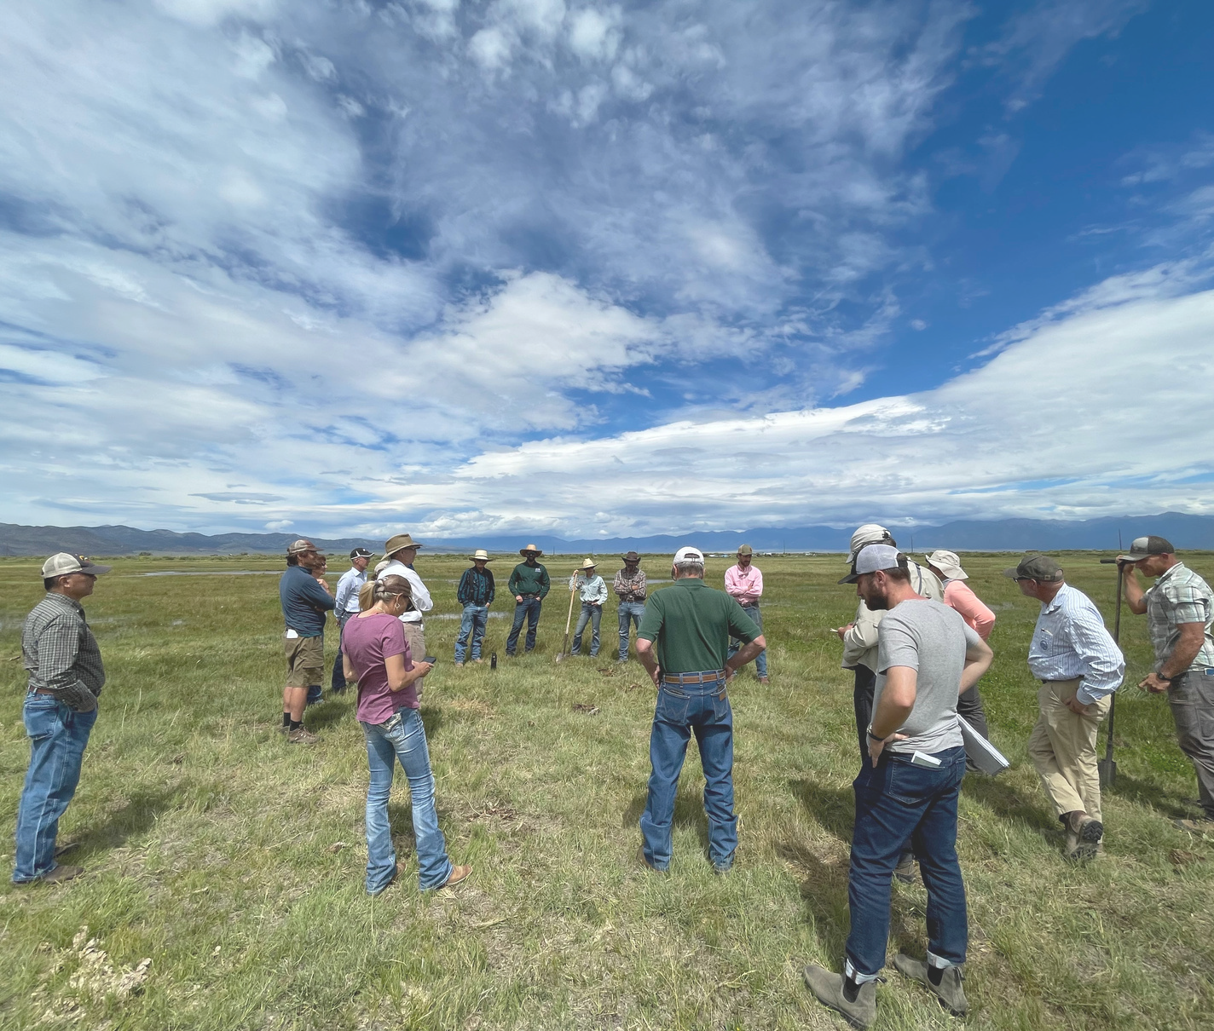
Mosca-Hooper Conservation District Annual Report
2024

Bringing Farmers Together Field Day August 24, 2024

Website: https://mhcd.colorado.gov/ Address: 101 S. Craft Dr. Alamosa, CO 81101 Telephone: 719-992-3661
Email: moscahoopercd1@gmail.com

MISSION STATEMENT
To provide leadership in natural resource management for the betterment of all present and future residents of the district through education and example.

DESCRIPTION
Established on June 7th, 1943, the Mosca-Hooper Conservation District (MHCD) includes the vast majority of Alamosa County.
Total acreage within the District is 462,000 acres.
317,000 acres are privately held and 145,000 acres are publicly held.
The District has a conservation history of 75+ years.

SUPERVISORS & STAFF
Bill Brinton, President Trudi Kretsinger, Treasurer Patrick O’Neill, Secretary
Matthew Martinez, Supervisor Derek Heersink, Supervisor
Larry Brown, Ex Officio Supervisor, CSU Extension SLV Area Director Marta Petermann, District Manager
Wayne Schwab, District Conservation Technician
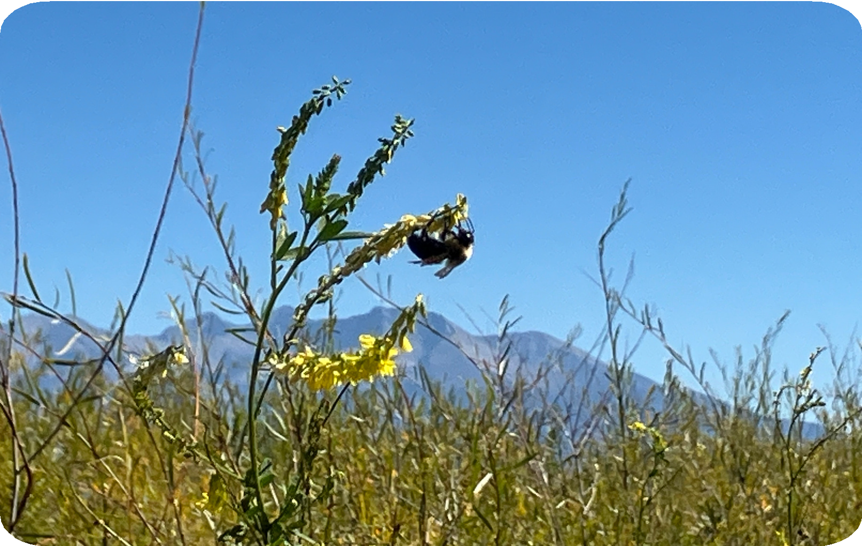

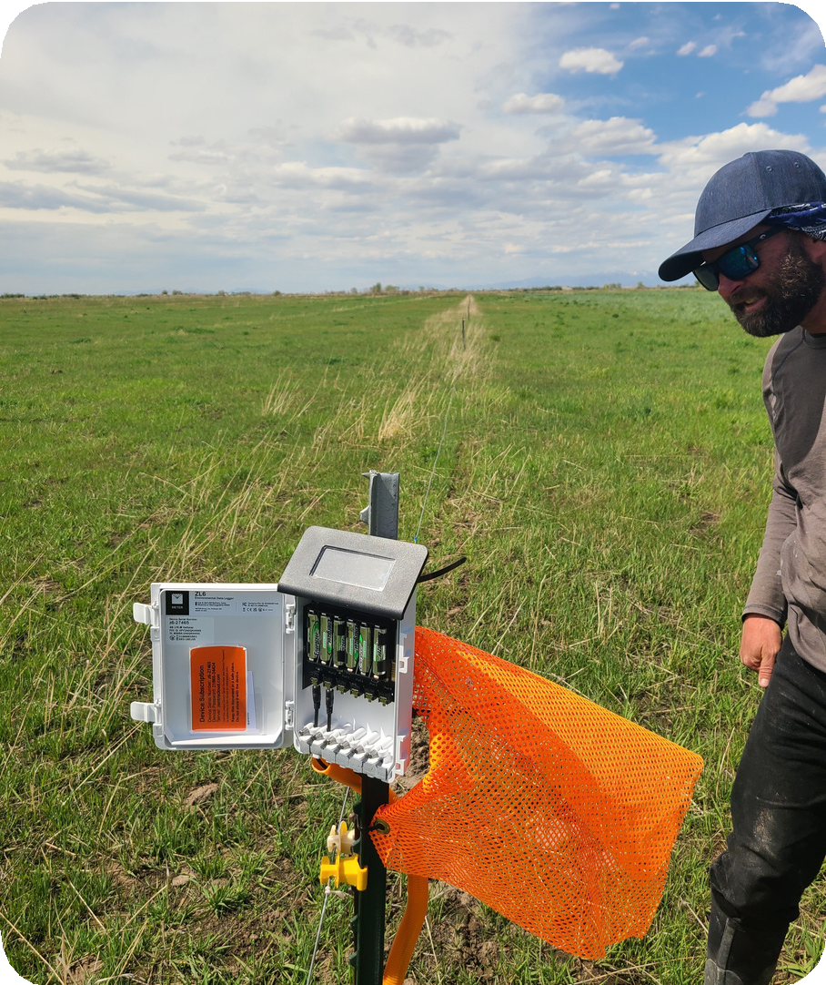
Colorado Soil Health Program

The first soil moisture sensor installation in spring, 2024,
by Toby McPartland, Southwestern Soil Health Specialist, CSHP
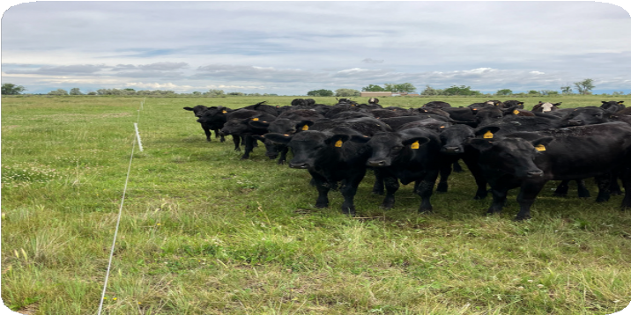

Prescribed grazing, summer, 2024

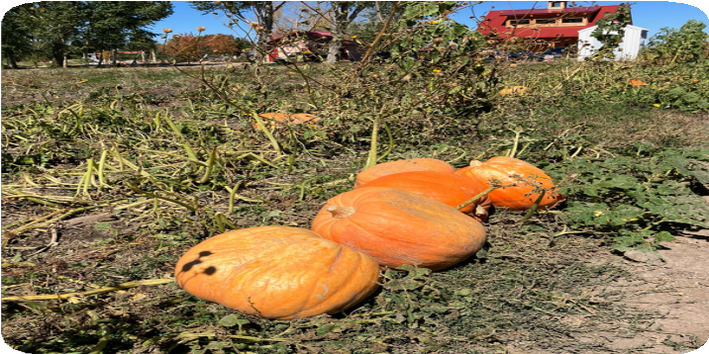
Polyculture of pumpkins, sunflowers and chard at vegetable harvest, fall, 2024
The Colorado Soil Health Program ( CSHP) of the Colorado Department of Agriculture ( CDA) provides funds
to Mosca- Hooper Conservation District ( MHCD) in support of
farmers and ranchers who implement new practices such as novel crop
rotations, cover cropping, prescribed grazing, compost applications and
reduced tillage. These practices can help build healthy soil, prevent
erosion, conserve water, sequester carbon and improve productivity.
For 2024 - 27 , MHCD has enrolled 13 farmers and ranchers in the CSHP.
MHCD also completed three seasons of support to seven farmers and
ranchers who were enrolled in the original Colorado STAR Plus soil health program from 2022 - 24 .

In 2024 , through the STAR Plus and Colorado Soil Health Programs,
MHCD expended $80, 350 in matching grant support to farmers and
ranchers who implemented new soil health practices.

Bringing Farmers Together
Implementing a Peer- to- Peer Learning Network in the San Luis Valley

This project began in January 2024 with the goal of creating and facilitating a collaborative learning network of agricultural producers to develop ideas and implement methods to increase soil water holding capacity and improve irrigation efficiency. MHCD enlisted the help of three host producers/ranchers to host 6 small group sessions with their neighbors and peers. These small groups shared their ideas and projects with one another while discussing water and soil conservation in the Valley.
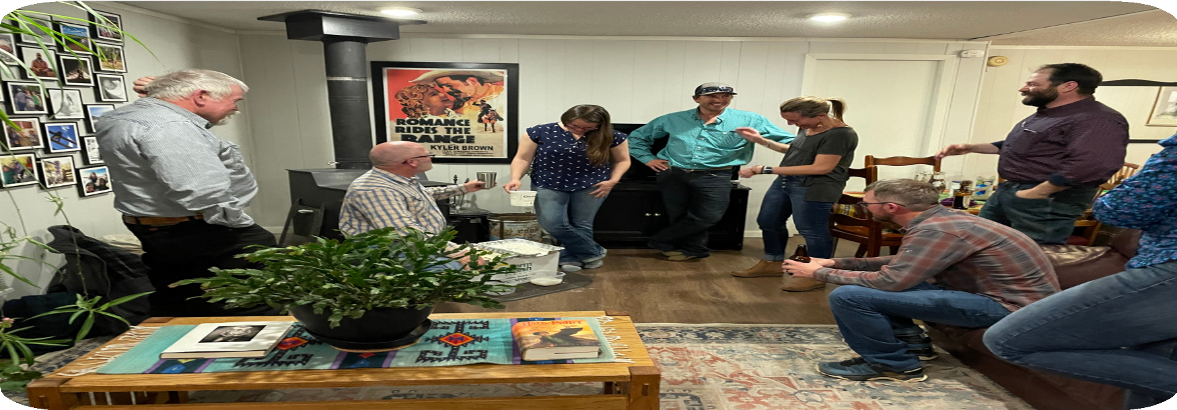
“Bringing Farmers Together…” small group peer-to-peer learning session, winter 2024. Standing at left is Peter Donovan, Technical Advisor.
Seated at left is Patrick O’Neill, Agricultural Technical Advisor.
Standing at right is Kyler Brown, Host Producer.
Photo credit: Seth Armentrout, Project Coordinator.

Bringing Farmers Together Field Day
In addition to the small group sessions, MHCD planned, marketed, and hosted a peer- to-peer Field Day on August 24, 2024. The Field Day featured conversations and field demonstrations at four farms/ranches. Mosca-Hooper collaborated closely with the Center and Rio Grande Conservation Districts to arrange a program focused on water and soil conservation the night before the Field Day.
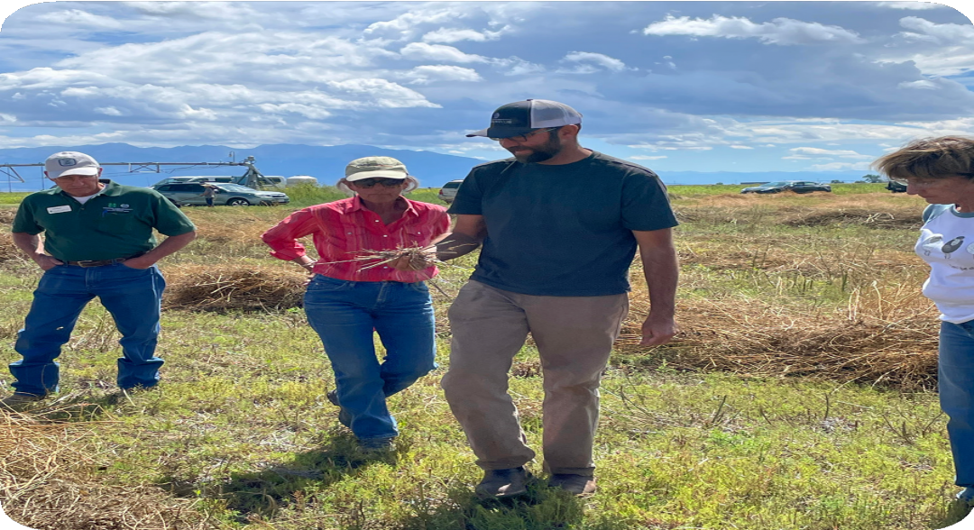
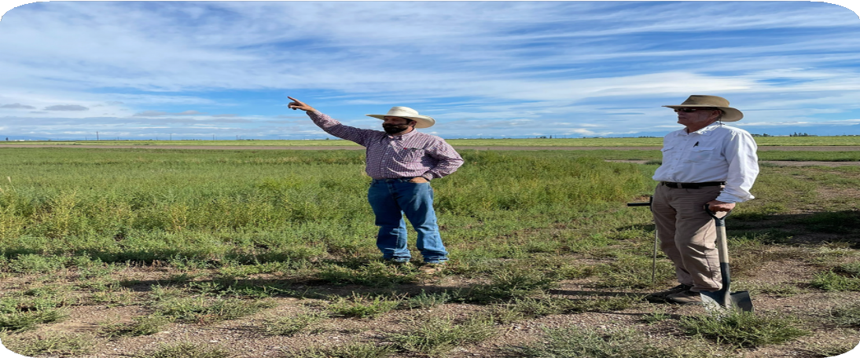
There were 32 participants at the Field Day..
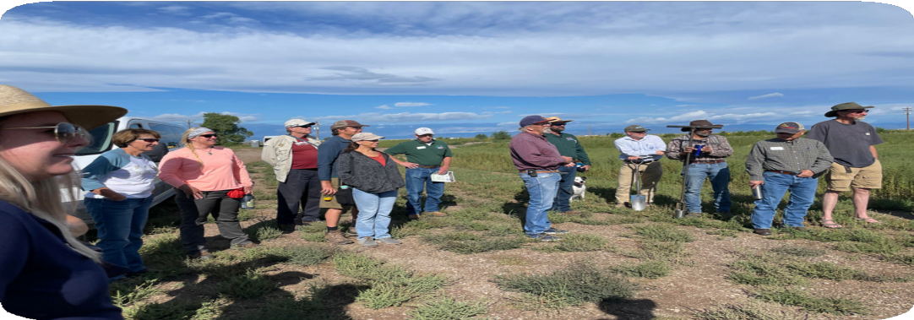
Photos on the top left and top right were taken at Host Producer Kyler Brown’s field.
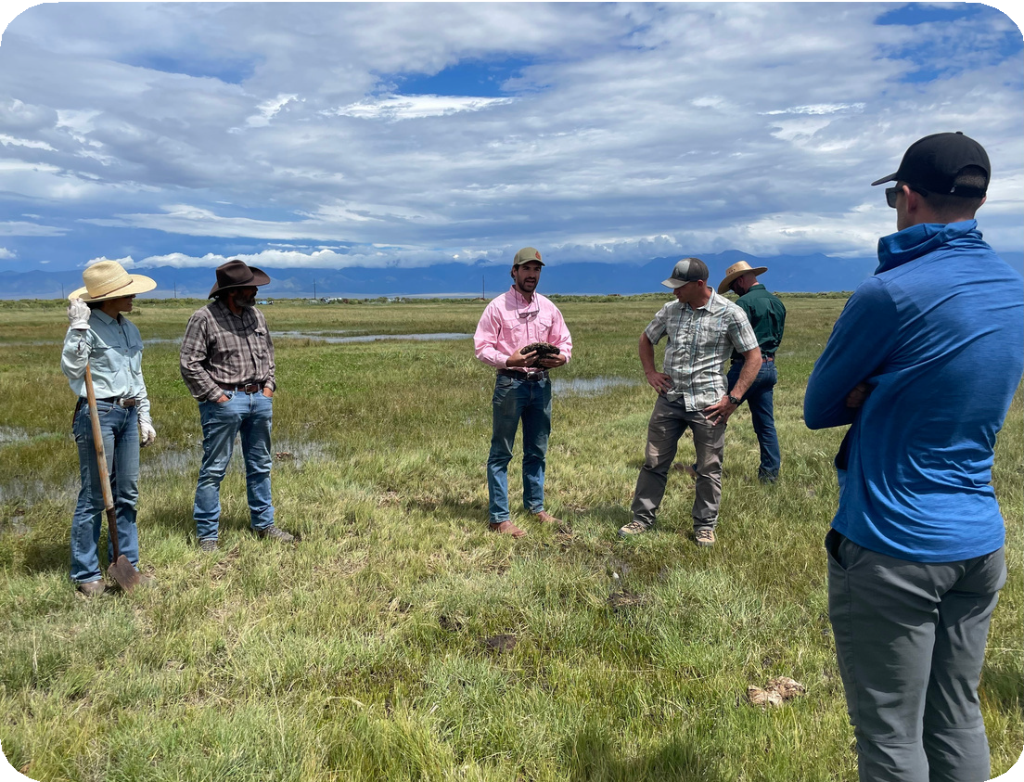
Bottom left photo taken at Host Producer Rob Jones’ farm. Here Michael Jones talks with the group about his family’s cover crop.
Bottom right photo: Host Producer Sam Schmidt at San Juan Ranch speaks about rotational grazing, irrigation water management and soil health.

Bringing Farmers Together Continued
Soil health practices vary dramatically across the San Luis Valley.
Often, the desire is simply to keep soil from blowing away.
Farmers and ranchers often struggle to implement principles of soil health, due to timing, cost, and knowledge gaps.
Nevertheless, some farmers and ranchers have been leading the way in maintaining healthy soils, and tying these efforts into water conservation. Project participants exchanged a wide range of ideas and experiences such as: introducing prescribed cattle grazing in cropping systems, utilizing data from soil moisture sensors to make real-time irrigation decisions, applying new amendments such as wool pellets and fungal-based compost, and growing and marketing new water-saving grain crops in rotation with potatoes.

Patrick O’Neill, Agricultural Technical Advisor, who consulted at some of the small group sessions, provided user friendly demonstrations of water infiltration, soil temperatures, and soil moisture meter operation.
The photos below were taken at Host Producer Rob Jones’ farm.
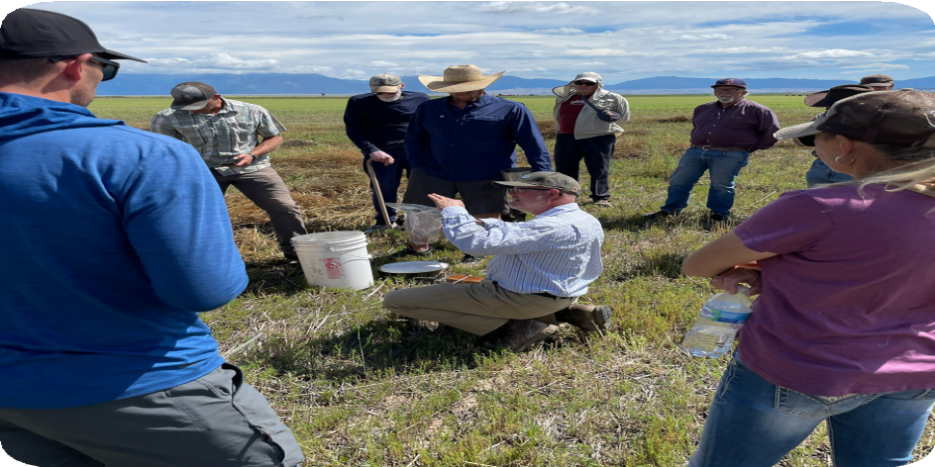
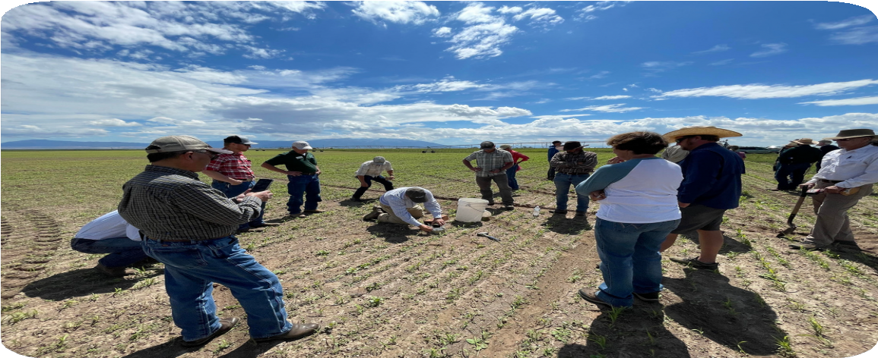

Learning about the Wool Pellet Project during the Field Day
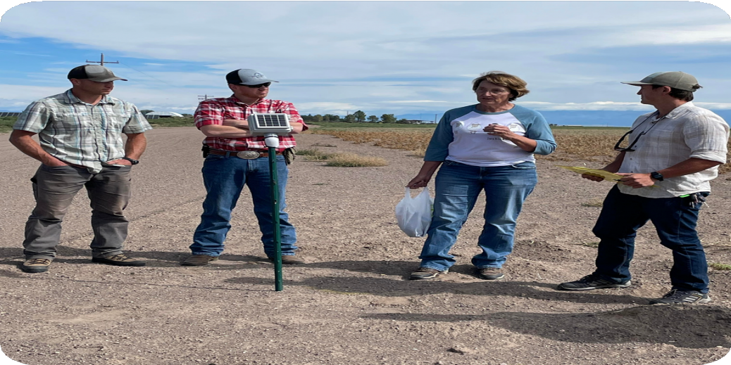
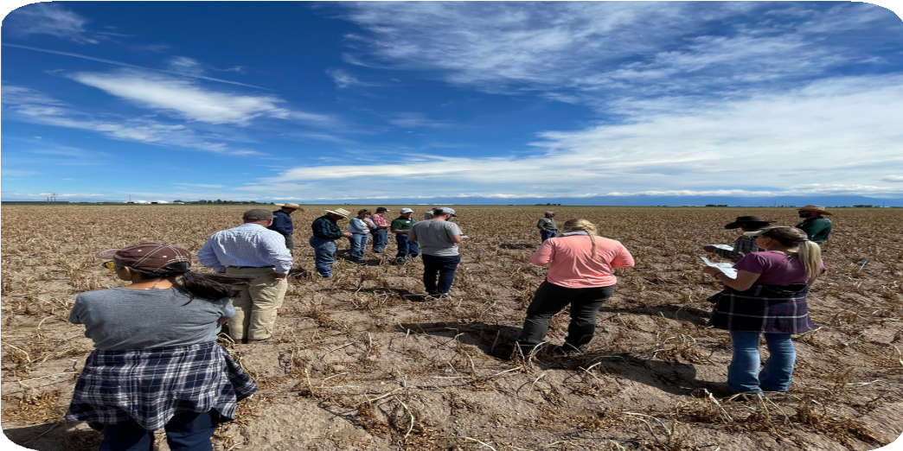

Sherry Haugen speaks to the group about using wool as a water retention tool. Patrick O’Neill spoke to the group about the soil moisture sensor that is in the middle of the group.

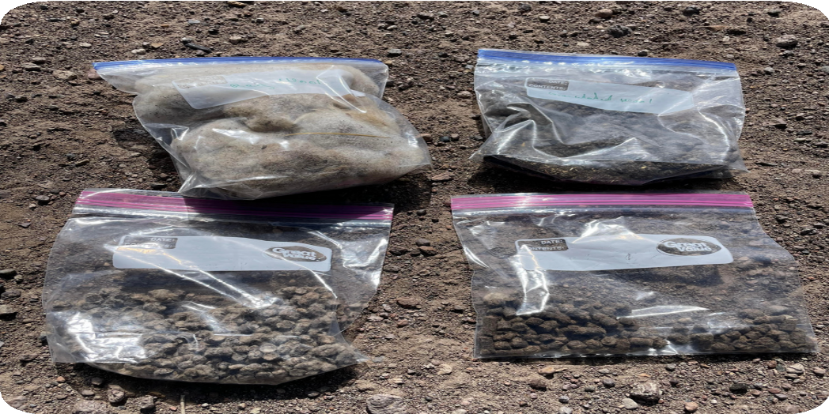
The various stages of turning wool into pellets.
Field Day participants inspect a test plot of wool pellets in a potato field ready for harvest
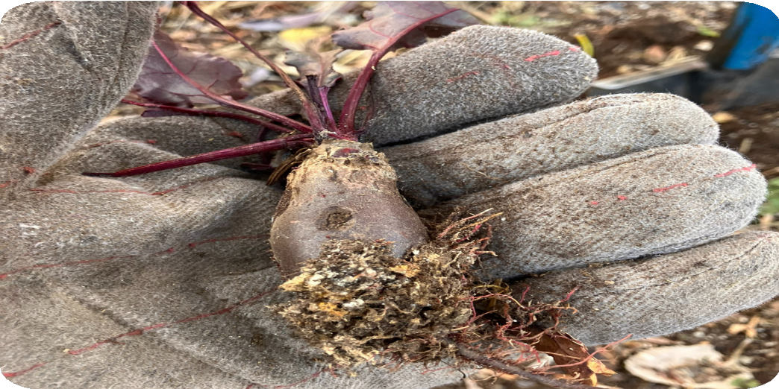
Wool pellets on beet rootlets.

Dust-On Snow and the National Wind Erosion Monitoring Network
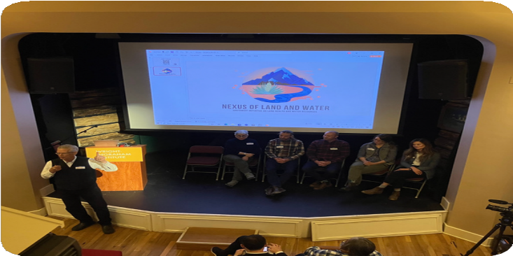
Dust storms originating from the 4-corners region deposit particulate material on the snowpack of the San Juan Mountains. This “dust-on-snow” can lead to reduced snow water content and earlier spring runoff, thus reducing stream flows and water for surface irrigation. Research to date has focused on western Colorado; there is limited information about the effects of dust-on-snow on the east slope of the San Juan Mountains. In late October, MHCD supervisors Bill Brinton, Larry Brown and Patrick O’Neill participated in a three-day symposium, held in Cortez and sponsored by the Wright- Ingraham Institute and

President Bill Brinton speaks to the group of the potential effects of dust-on-snow on snowpack and spring run-off in the San Luis Valley.
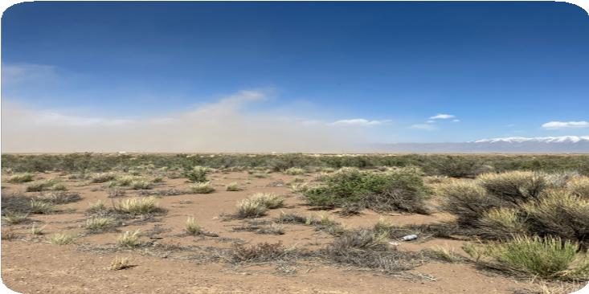
Alamosa County Dust Storm May 2024
Mountain Studies Institute. More than 20 “problem solvers” from across the country, including visual artists, media experts, historians, climate scientists and natural resource specialists convened to share ideas and experiences, and prepare a presentation which was attended by over 80 community members. Finding solutions to dust-on-snow will be a long-term challenge.

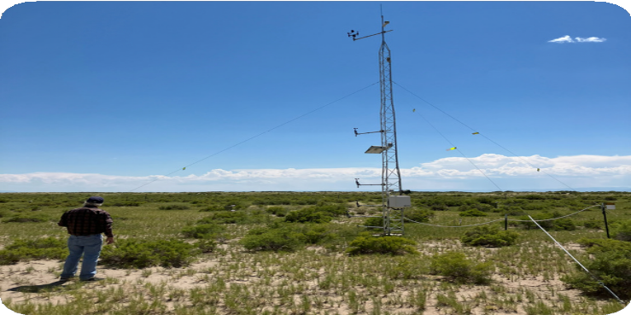
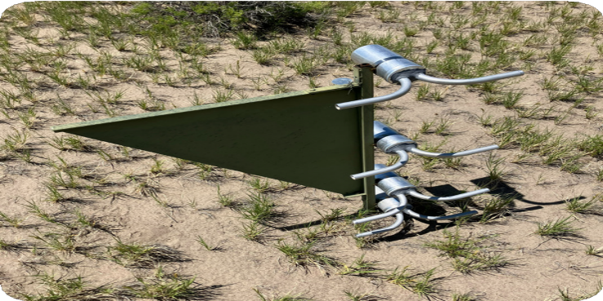
MHCD is committed to reducing soil wind erosion in Alamosa County. In 2024, The National Wind Erosion Research Network (NWERN) contacted MHCD to request assistance in staffing the NWERN weather station near San Luis Lakes. A stipend from the Wright-Ingraham Institute will provide support for the MHCD District Conservation Technician to maintain, and collect data from, the NWERN SLV site.

Photos on the left and right were taken at the National Wind Erosion Research Network SLV Site.
Photo on the right shows Wayne Schwab, District Conservation Technician visiting the site.
Photo Credit: Bill Brinton

The Coffee Break Project and COMET Trainings
The Coffee Break Project began in southeast Colorado in 2018 in response to multiple suicides among local agricultural workers. Beginning in late 2023, stakeholders, including MHCD, worked to bring this grass-roots rural mental health program to the San Luis Valley. The SLV Coffee Break Project is led by JC Carrica, Ed.D. of Valley-Wide Health Systems, Inc., and the Colorado State University Extension, San Luis Valley Area.

In 2024, the SLV Coffee Break Project hosted events to raise public awareness about emotional stress and mental health among rural residents, and held multiple COMET (Changing Our Mental and Emotional Trajectory) trainings to teach community members how to engage and assist persons who are experiencing emotional stress. The MHCD Board of Supervisors
attended a COMET training on April 29.

Stay tuned for more developments from the SLV Coffee Break Project.
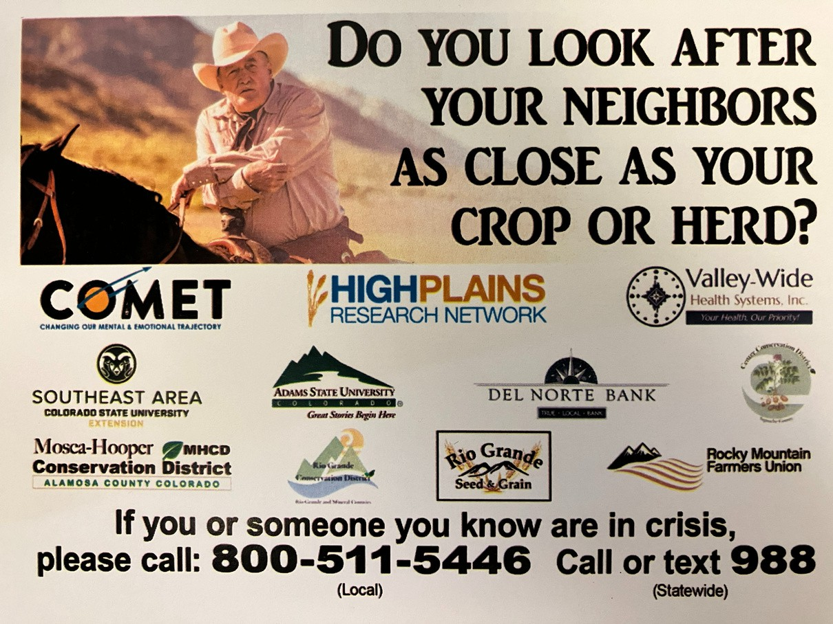
For more information see: www.thecoffeebreakproject.org.

Summary of MHCD Projects and Support of Conservation Education

Sponsored RGWCEI youth conservation programs at SLV area schools. Provided compost extract equipment rentals for local producers.
Co-hosted the Annual Local Work Group meeting with the Rio Conservation District and Center Conservation District on February 8, 2024. This meeting gave District land managers an opportunity to meet and talk with staff from the Natural Resources Conservation Service, the Colorado State Conservation Board, and the Districts while discussing their resource concerns.
Sponsored three competitive awards for projects related to soil health/soil conservation at the 2024 SLV Regional Science Fair in Alamosa.
Provided scholarships for 10 students from Adams State to attend the Southern Rocky Mountain Agricultural Conference in early February.
Provided plaques for the top contenders of the 2024 SLV FFA Range Judging Contest.
Board President Bill Brinton presented at the Ag Conference in Monte Vista about the Colorado Soil Health Program.
Provided funding for District Staff and Board Supervisors to attend the Colorado Association of Conservation Districts workshop in Colorado Springs.
Approved a 3-year (long term) operations plan which includes a new initiative for rural mental health and suicide prevention.

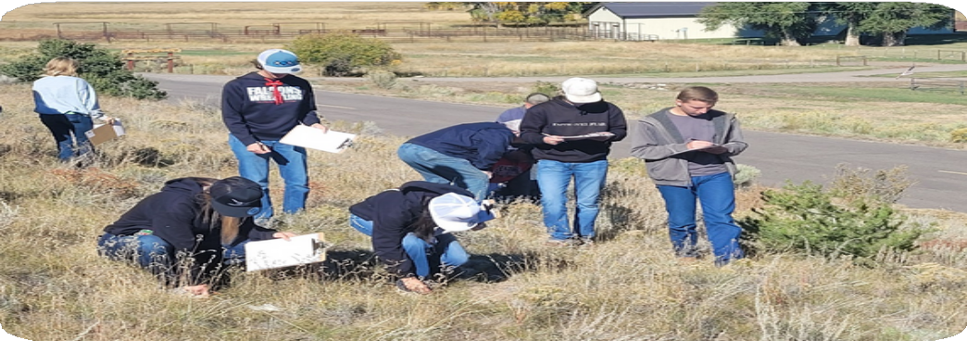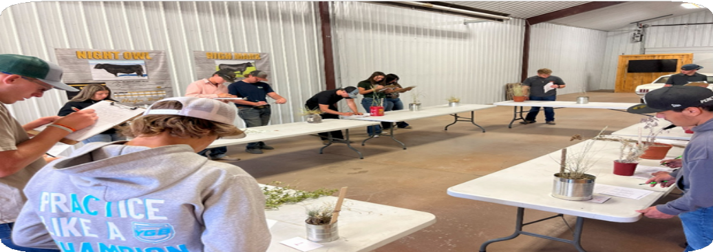

42 agriculture students, representing five FFA chapters in the region, participated in the SLV FFA Range Judging and Plant Identification Competition near La Garita.
Photo Credit: Hannah Thill, RGWCEI
Students work on identifying different plant species at the SLV FFA Range Judging Competition October 2, 2024.
Photo Credit: Center Conservation District

2024 FINANCIAL SUMMARY

MHCD sincerely thanks these organizations for providing a total of $126,380.05 to support District projects:

Colorado Department of Agriculture Colorado State Conservation Board Wright-Ingraham Institute
Colorado Association of Conservation Districts Western SARE Planning Grant

Assets: $187,468.74 Fixed Assets: $21,363.00 Total Assets: $202,261.74
Total Liabilities & Equities: $202,261.74 Statement of Comprehensive Income Income: $156,611.07
Expenses: $97,292.45 Net Income: $57,578.62

