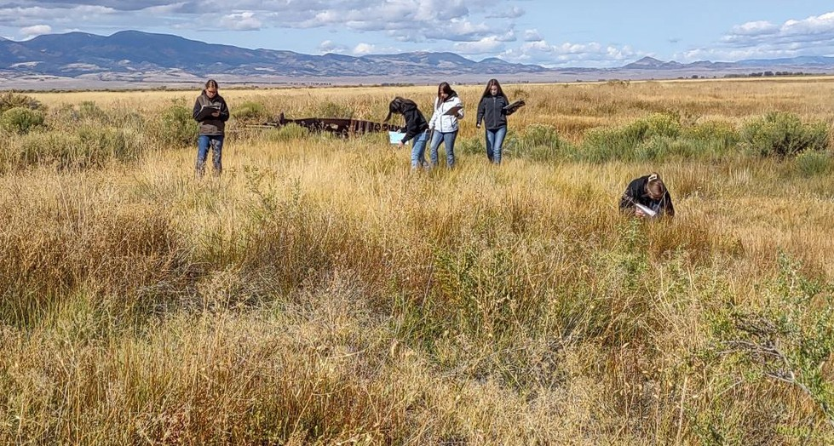
Mosca-Hooper Conservation District Annual Report
2023

Students studying a Salt Flat Ecological Site- part of the FFA Regional Range Judging Event.

Email: moscahoopercd1@gmail.com Website: https://mhcd.colorado.gov/ Address: 101 S. Craft Dr.
Alamosa, CO 81101
Telephone: 719-992-3661

During the competition students were required to identify 20 range plant species and one ecological site. During the plant identification portion students had one minute to identify the plant before moving on to the next plant. At the ecological site, students had to complete a rangeland inventory to determine the vegetation composition and rangeland condition of the site and analyze the condition of the soil surface for protection from erosion.
Judging the ecological site also tested the students plant identification skills.

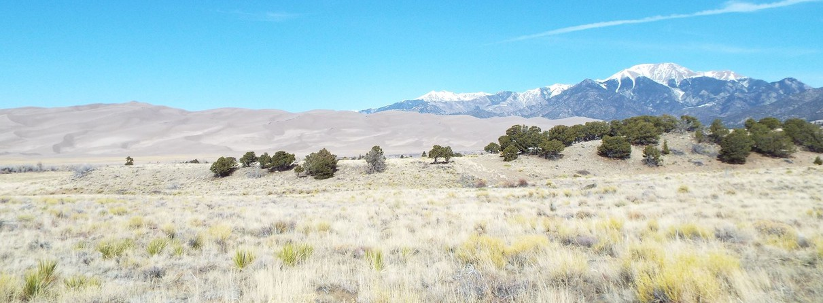
MISSION STATEMENT
To provide leadership in natural resource management for the betterment of all present and future residents of the district through education
and example.

DESCRIPTION
Established on June 7th, 1943, the Mosca-Hooper Conservation District (MHCD) includes the vast majority of Alamosa County.
Total acreage within the District is 462,000 acres.
317,000 acres are privately held and 145,000 acres are publicly held.
The District has a conservation history of 75+ years.

SUPERVISORS & STAFF
Bill Brinton, President Trudi Kretsinger, Treasurer Patrick O’Neill, Secretary
Matthew Martinez, Supervisor
Larry Brown, Ex Officio Supervisor, CSU Extension SLV Area Director Marta Petermann, District Manager
Sam Bradfield, District Conservation Technician

Saving Tomorrow's Agricultural Resources (STAR) Plus Program
The Colorado Department of Agriculture approved MHCD’ s request to enroll additional STAR Plus farm and ranch fields beginning in 2024 .
Recruitment is ongoing.
The STAR Plus program provides support for producers to begin new practices such as crop rotations, prescribed grazing, cover cropping,
compost application, and reduced tillage, which can build soil, prevent erosion, conserve water, and improve productivity.
MHCD continued to provide support to 7 producers who enrolled in the STAR Plus program in 2022. Prescribed grazing practices for four of these
producers are pictured below.

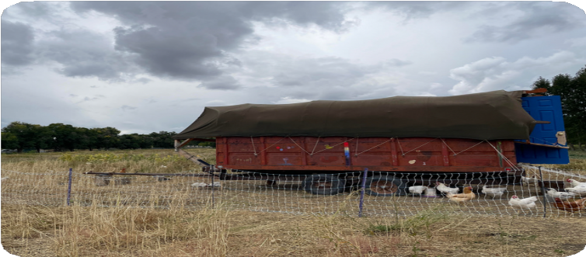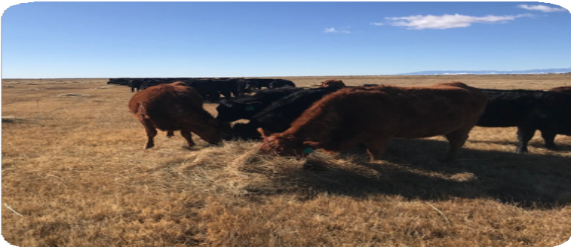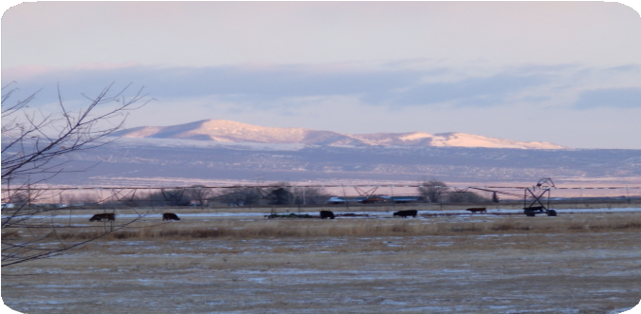

Summer grazing of a spring planted cover crop by chickens at the
Rio Grande Farm Park.
*Photo by: Seth Armentrout
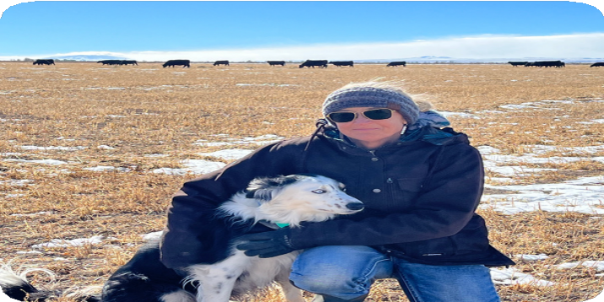
Fall grazing of small hay stacks at San Juan Ranch
Photo by: Sam Schmidt
Winter grazing at Raymond and Mary Shahan’s Ranch Photo by: Bill Brinton

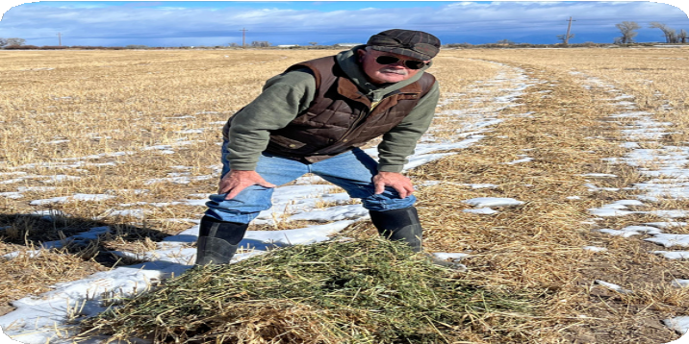
Leah and Pete Clark (left) demonstrate winter grazing of cover crop windrows on their Star Plus field of
7L Diamond Ranch.

Watershed Meeting
MHCD hosted the quarterly watershed meeting with Rio Grande and Center Conservation Districts
on December 12, 2023 .

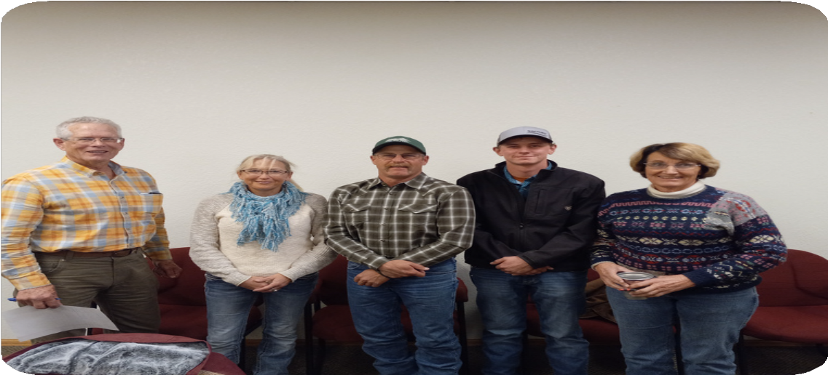

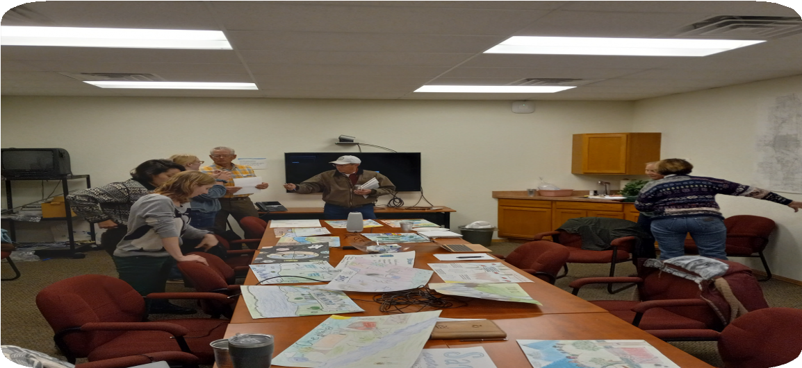

Hannah Thill, (Director of Rio Grande Watershed Conservation and Education Initiative) in left foreground, and Board Supervisors.
Conservation Poster Contest Judging
*Photos by: Garth Schaefer

Left to Right: Bill Brinton (MHCD), Leah Clark, Tyler Neely and Bryton Burkhart (Rio Grande Conservation District) and Sherry Haugen (Center Conservation District)

Events and Outreach
San Luis Valley FFA Range Management and Judging Workshop 2023
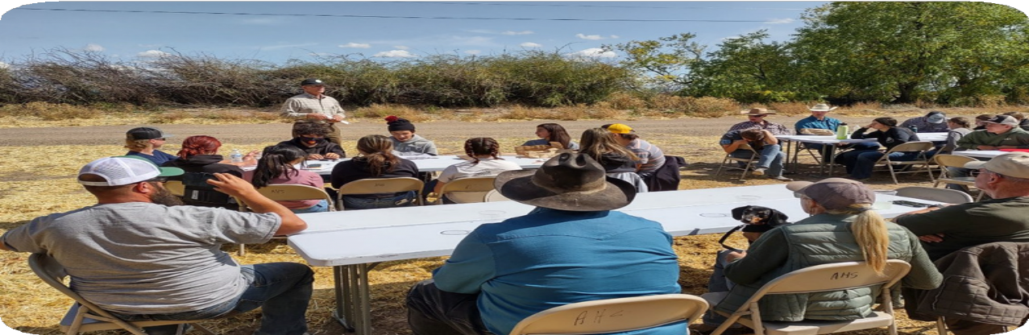
Bill Brinton speaks about Conservation Districts and soil health during the FFA Regional Range Judging event.

High school agriculture students from across the San Luis Valley competed in the FFA Range Judging and Plant Identification workshop held at the Monte Vista Wildlife Refuge and the 7L Diamond Ranch. Ben Berlinger and Dan Perez (NRCS Range Specialists based at Rocky Ford and Alamosa), Matt Sinclair and Matt Martinez (agriculture teachers at Sangre de Cristo High School and Alamosa High School), and Hannah Thill (Rio Grande Watershed Conservation & Education Initiative – RGWCEI) led this daylong workshop for high school students.
MHCD and RGWCEI provided funding to support this youth educational event.
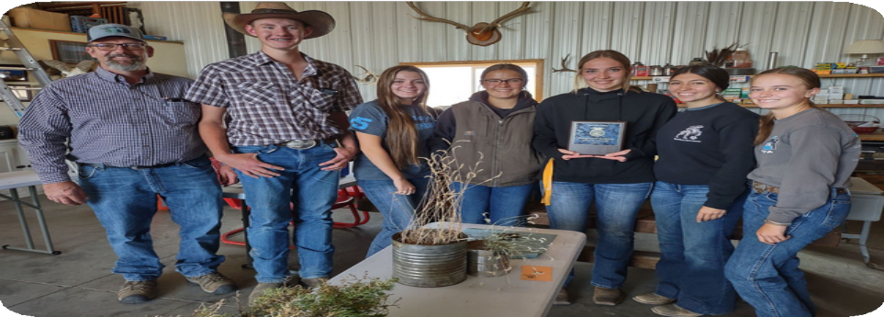
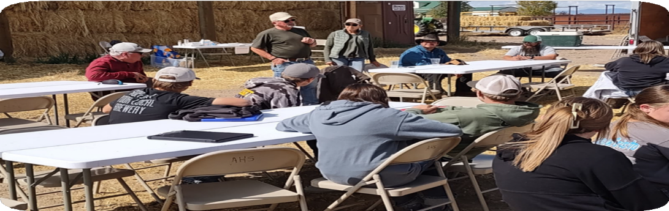

Sangre De Cristo High School won 1st place for this year’s FFA Range Judging Contest.
Plaques were sponsored by MHCD.
Pete and Leah Clark share their knowledge of cattle range grazing with students.
*Photos by: Ben Berlinger

Finding New Ground: Sustainable Agriculture Action Plan with Western SARE
MHCD was awarded a Sustainable Agriculture Action Plan grant funded by Western SARE – Montana State University. MHCD brought together farmers, ranchers, and other stakeholders to hear their resource concerns, share experiences, exchange ideas for improving resource management and achieving personal and community goals.
In 2023, MHCD supervisor Patrick O’Neill with consultants Jeff Goebel and Peter Donovan, conducted 26 interviews with individuals and small groups, including San Luis Valley (SLV) farmers and ranchers, the
SLV Area CSU Extension Service, local NRCS Staff, and the Rio Grande Water Conservation District.
Participants identified systemic barriers to change in agricultural practices. For example, many producers lack a voice in decision-making about resource allocation, and there are existing incentives to
overuse (instead of conserve) water. But participants also expressed faith in teamwork and community building. “I learned people may be ready to work cooperatively toward shared success.”
“I learned there are others working in the same field.”
There was also a strong interest in continued participation, and most were optimistic about collaborating to address the issues, and hopeful and committed to continued group effort to address the issues.
“There is a core of people willing to do something,” and to support efforts that are underway.
To read the final report visit MHCD’s website at: https://mhcd.colorado.gov/ and click on the Projects tab at the top of the home page.

In 2024, MHCD will be working with farmers and ranchers to continue their efforts in establishing peer-to-peer learning networks in
the San Luis Valley.

Summary of MHCD Projects and Support of Conservation Education
Sponsored RGWCEI youth conservation programs at SLV area schools. Supported RGWCEI youth summer conservation camps.
Provided compost extract equipment rentals for local producers. Hosted a quarterly meeting of the Rio Grande Watershed Association of Conservation Districts on December 12th, 2023.
Provided funding for and helped with judging the National Association of Conservation Districts annual poster contest for 6th grade students in the SLV. Hosted on May 11, 2023, an annual Local Work Group meeting of District land managers with staff from NRCS and the Colorado State Conservation Board (CSCB), for attendees to discuss their resource concerns with MHCD, NRCS and CSCB. Sponsored three competitive awards for projects related to soil health/soil conservation at the 2023 SLV Regional Science Fair in Alamosa.
Sponsored Adams State University Business Ag students to remotely attend the three-day Quivira Conference in Albuquerque.
Created a new District Conservation Technician position for providing field services such as soil sampling and placement of soil moisture sensors.
Provided training on February 13, 2023 ; taught by Lucas Casias, Noxious Weed Coordinator, Costilla County.
Made a presentation on February 8th at the Ag Conference in Monte Vista on the STAR and STAR Plus initiatives of the Colorado Department of Agriculture -Soil Health Program.

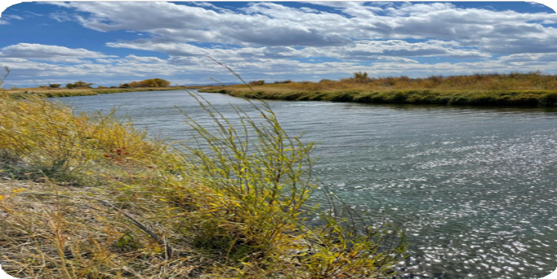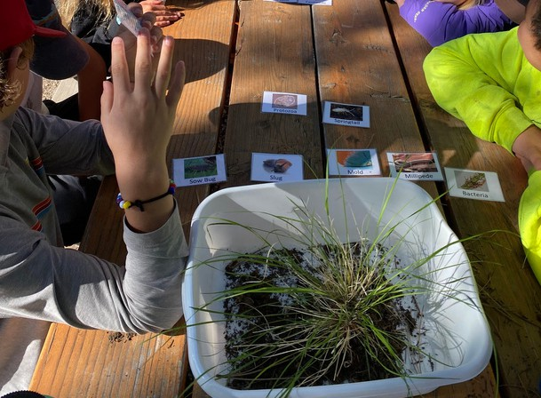

Alamosa Wildlife Refuge
*Photo by: Marta Petermann
Students identifying what lives in the soil at Conservation Camp
*Photo by: Hannah Thill

2023 FINANCIAL SUMMARY

To support District projects, MHCD secured $81,498.47 in funding from:
Colorado Department of Agriculture
Colorado Water Conservation Board
Colorado State Conservation Board

Assets: $132,365.99 Fixed Assets: $21,363.00 Total Assets: $148,472.99
Total Liabilities & Equities: $148,472.99 Statement of Comprehensive Income Income: $86.391.97
Expenses: $76,124.71 Net Income: $8,527.26

