Mosca-Hooper Conservation District Annual Report

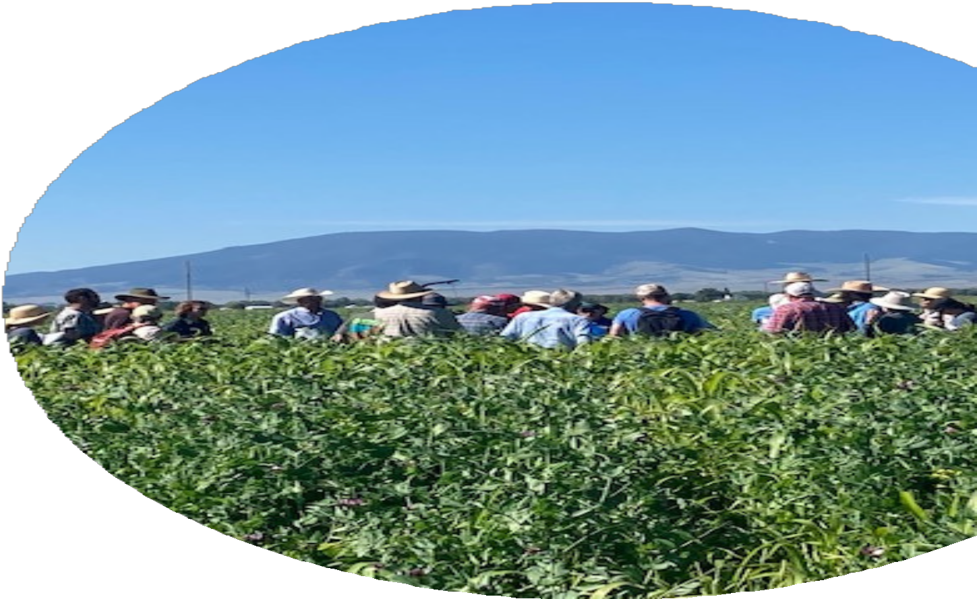

2022

Email: [moscahoopercd1@gmail.com](mailto:moscahoopercd1@gmail.com) Website: https://mhcd.colorado.gov/ Address: 101 S. Craft Dr. Alamosa, CO 81101 Telephone: 719-992-3661

# MISSION STATEMENT

To provide leadership in natural resource management for the betterment of all present and future residents of the district through education

and example.

# DESCRIPTION

Established on June 7th, 1943, the Mosca-Hooper Conservation District (MHCD) includes the vast majority of Alamosa County.

Total acreage within the District is 462,000 acres.

317,000 acres are privately held and 145,000 acres are publicly held.

The District has a conservation history of 75+ years.

**SUPERVISORS & STAFF**

Bill Brinton, President Trudi Kretsinger, Treasurer Patrick O’Neill, Secretary

Matthew Martinez, Supervisor Marta Petermann, District Manager

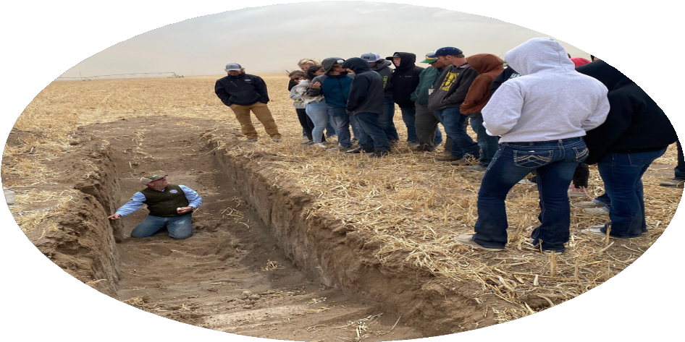 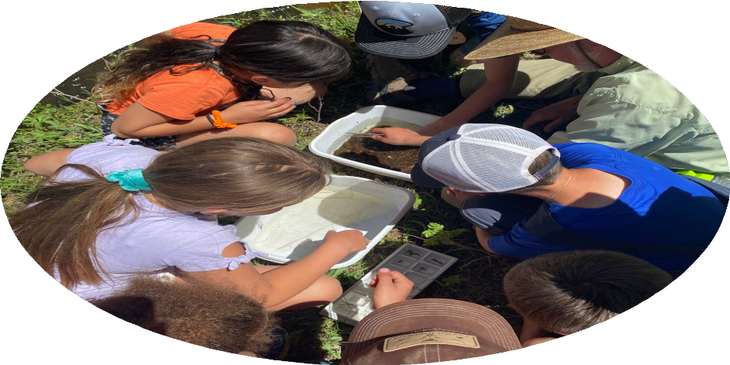

Patrick O'Neill teaching high school students about root structure and how water affects the soil chemistry and profile by comparing two soil pits: one with barley stubble and the other a cover crop.

**\*Photo courtesy of Hannah Thill**

Photo of campers studying aquatic macro- invertebrates at Beaver Creek Camp.

**\*Photo courtesy of Hannah Thill**

Saving Tomorrow's Agricultural Resources (STAR) Plus Program

MHCD enrolled 7 farmers and ranchers, over 1400 acres, in 3 counties of the San Luis Valley ( SLV) in

the Colorado Department of Agriculture ( CDA) STAR Plus Program to improve soil health.

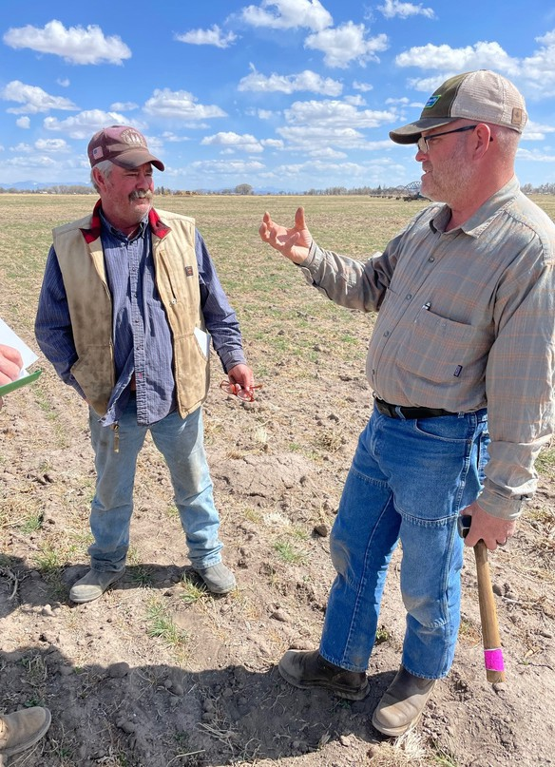 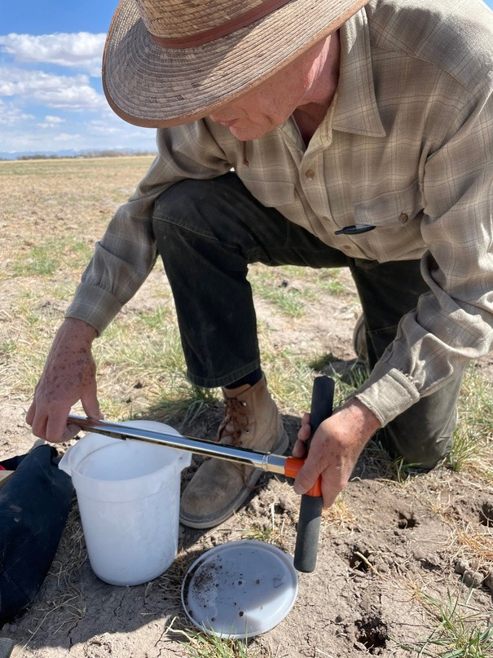

STAR Plus producer Raymond Shahan (left) at his farm with Patrick O'Neill (right)

Bill Brinton taking a soil sample at the Shahan's farm.

The STAR Plus program provided support to producers for cover crop planting, application of soil amendments such as compost, equipment for rotational grazing, and other methods to improve productivity, prevent erosion, and conserve water.

The STAR Plus program also distributed funds for equipment purchases including soil moisture sensors for STAR Plus farmers and ranchers and other producers.

Static Pile Fungal-Rich Vermicompost

Visit to the static pile compost production site with Commissioner Greenberg

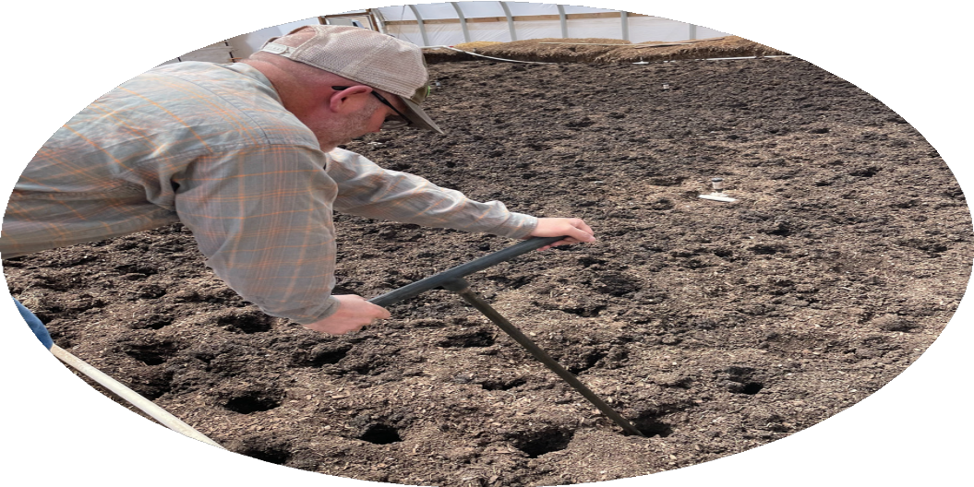 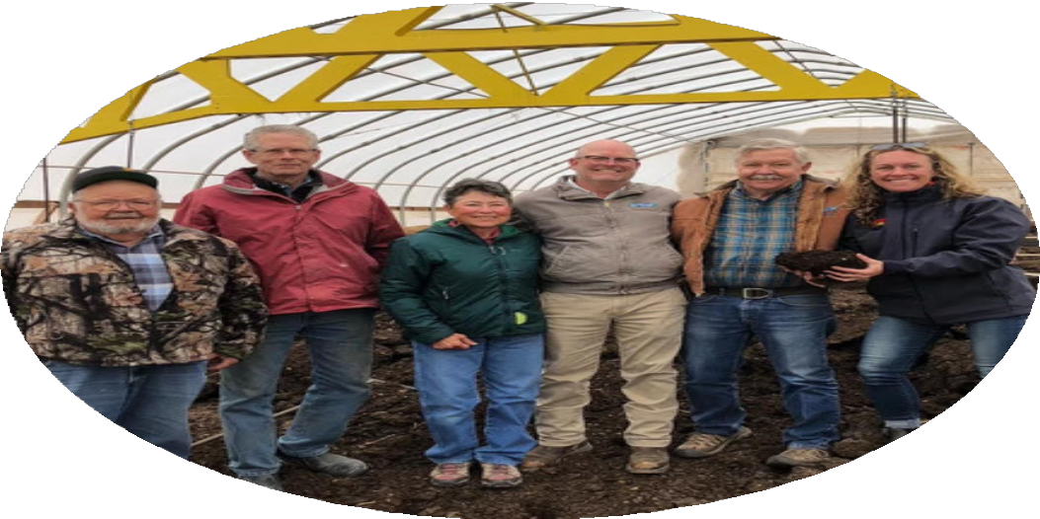

Patrick O'Neill extracting compost from the vermicompost site.

From left to right: Dave West, Bill Brinton, Kelly West, Patrick O'Neill, John West, and CDA Commissioner Kate Greenberg

Dave, Kelly, and John West of Fungal Link LLC hosted MHCD supervisors and Kate Greenberg, Colorado Commissioner of Agriculture, at the static pile compost production site in

Jaroso, Colorado

MHCD will continue to partner with Fungal Link LLC to promote the use of fungal- rich compost to improve soil biology and

productivity at numerous farms and ranches.

MHCD provides funds for soil testing and crop production analysis at 14 farms as part of the multi- year Static Pile Compost Project.

Events and Outreach

"Hold Your Ground Farm Tour and Seminar"

August 13, 2022 Hosted by CDA, MHCD, and Acres USA

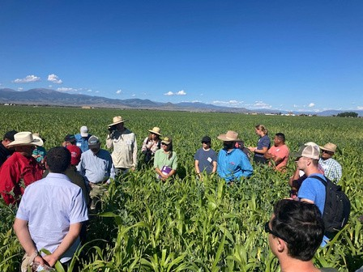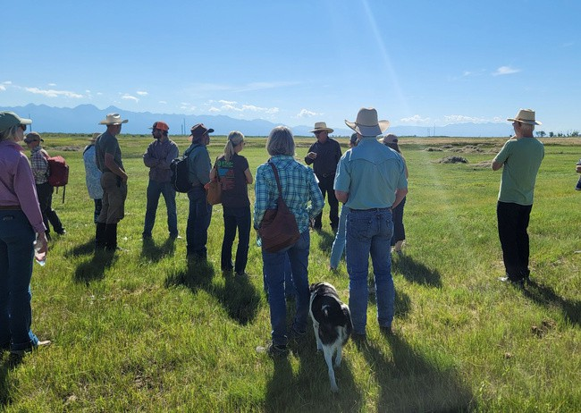

Keynote speaker Jimmy Emmons (left) and STAR Plus producer Kyler Brown (right) discuss his lush cover crop with the tour group at Elliott Farms

STAR Plus producer George Whitten (top center) explains his soil- centric ranching practices with the tour group at San Juan Ranch.

This was the f irst regional STAR Plus Event in the State. Over 50

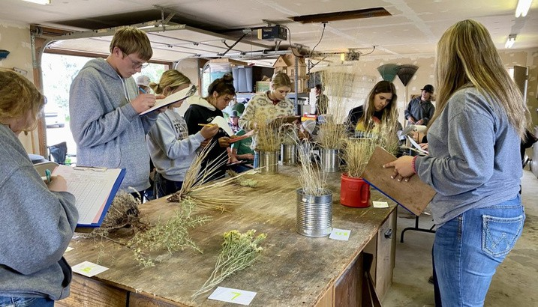

Coloradans attended f ield tours at Elliott Farms in Rio Grande County and San Juan Ranch in Saguache County, followed by classroom sessions on

soil health at the Ski Hi Complex in Monte Vista.

**San Luis Valley FFA Range Management and Judging Workshop 2022**

High school agriculture students from Alamosa County competed in the FFA Range Judging and Plant Identification workshop held on Sept. 21, 2022 at Nick Berlinger's farm near Alamosa.

This event was co-led by Ben Berlinger from the NRCS office in La Junta and Hannah Thill from the Rio Grande Water Conservation and Education Initiative (RGWCEI) program in Alamosa, with added support from Trudi Kretsinger and Bill Brinton at MHCD, Matt Martinez at MHCD and Alamosa High School Ag Program, and Matt Sinclair from the Sangre de Cristo High School Ag Program.

Education and Support

 Continued sponsorship of other RGWCEI programs in area schools and the Beaver Creek summer youth conservation camp.

 MHCD provides compost extract equipment rentals for local producers.  MHCD hosted a quarterly meeting of the Rio Grande Watershed

Association of Conservation Districts on June 7th, 2022.

 Provided funding and helped with judging the National Association of Conservation Districts annual poster contest for 6th grade students in the San Luis Valley.

 Provided funds for the District Manager to attend conservation finance bootcamp virtually through Colorado State University.

 Hosted a Local Work Group meeting in July with producers, board supervisors, and NRCS staff at the Rio Grande Farm Park in Alamosa. This meeting provided input to NRCS from the producers about their resource concerns.

 Sponsored three competitive awards for projects related to soil health/soil conservation at the upcoming 2023 SLV Regional Science Fair in Alamosa.

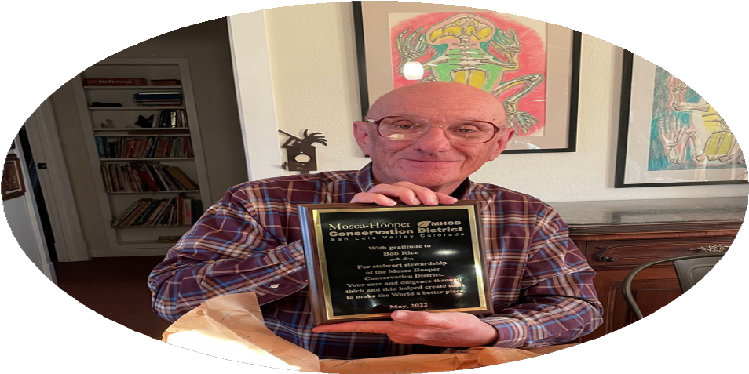Honoring Robert Rice

Presenting a plaque to honor Robert Rice for his role as

Mosca- Hooper Conservation District President ( 2020 - 2022 )

and Supervisor ( 2018 - 2020 ) .

**2022 FINANCIAL SUMMARY**

**MHCD Secured $146,551.94 in combined funding to support District Projects from:**

**Colorado Department of Agriculture Colorado Water Conservation Board Colorado State Conservation Board COVID Relief Fund**

**Assets: $125,414.22 Fixed Assets: $21,363.00 Total Assets: $142,835.22**

**Total Liabilities & Equities: $142,835.22 Statement of Comprehensive Income Income: $161,240.39**

**Expenses: $138,049.02 Net Income: $22,696.37**

