Mosca-Hooper Conservation District

Bringing Farmers Together: Implementing a Peer-to-Peer Learning Network in the San Luis Valley
Year 2

Erin Kauffman, Project Coordinator
Marta Petermann, District Manager
moscahoopercd1@gmail.com

October 10, 2025

Narrative
As the San Luis Valley continues to face long-term drought, farmers' livelihoods and ability to continue farming face increasing threats. At the beginning of the 2025 growing season, the snowpack in the San Juan mountains (which provides much of the water to the Valley) was less than 40% of the 20-year average. In addition, aquifer levels continue to drop due to over-appropriation. Farmers and ranchers are facing the reality of disappearing surface water and groundwater resources and a drier landscape overall, which jeopardizes the region's agricultural economy and community.
Bringing Farmers Together: Implementing a Peer-to-Peer Learning Network in the San Luis Valley seeks solutions from the bottom up through idea sharing among farmers and ranchers who are experimenting with and implementing innovative practices to reduce their water use at the farm and ranch level. The top-down solution to the problem is to shut off more agricultural wells, but San Luis Valley farmers and ranchers have strong commitments to adapting their growing practices to the increasingly arid environment. These adaptations range from integrating cover crops to transitioning to less water-intensive forage mixes to making measurable commitments for how much water they return to the aquifer each year. This project aims to facilitate the spread of these ideas and practices to have a greater impact across the San Luis Valley.
Bringing Farmers Together continued from 2024, when three small groups were established to share ideas and create accountability for implementing practices that would help to conserve water. In 2025, two of these groups continued to meet, and two new small groups were formed. Some of the practices discussed were then displayed to a larger audience during a summer Field Day. The discussion-based format of the Field Day mirrored the peer learning model practiced in the small group sessions to generate further conversation and idea sharing.
Four "Host Producers" each gathered a small group that could meaningfully discuss water-conserving practices. One group was primarily potato farmers, another vegetable growers, a third cattle ranchers, and the fourth a mix of diversified cropping and livestock producers. Most groups were regionally based, made up of producers who were located close to each other within the San Luis Valley.
Each Host Producer was provided with training in facilitation skills from Peter Donovan (Technical Advisor) and Patrick O'Neill (Agricultural Technical Advisor). These trainings were hosted on Zoom early in the year, and at least one of these experts was able to attend the small group sessions to provide support and feedback to Hosts as needed.
The Host Producers then hosted two small group sessions each, often around the dinner table. An introduction circle started each gathering, where each person in the room introduced themselves and responded to a question related to their experience with water. Some conversations then covered higher level perspectives on water policy in the San Luis Valley, needs for better marketing opportunities to support farms long-term, and what it means to raise kids on a farm in this context. Others focused on the practical details of water-conserving practices such as integrating cover crops into potato rotations, integrating livestock in crop fields, and improving irrigation infrastructure. Most sessions ended with a closing circle, where each person shared something they learned or would take away from the conversation. Thirty-eight individuals participated across all eight small group sessions.
Participants in the small group sessions, community conservation partners, and the public were then invited to a Field Day on July 19. The Field Day was bookended by introduction and closing circles mirroring the small group sessions to facilitate community connections and participation. During the opening of the event, Patrick O'Neill gave a demonstration of the online OpenET tool using a field that was part of the tour as a resource for monitoring and decision-making related to plant water use. During the Field Day, the group visited three farms and ranches representing three of the four small groups. At the first stop, a producer shared his experiences using crimped rye as a cover crop in a potato rotation, and described their farm's goal to return 20% of water applied to the aquifer each year. At the second stop, a producer demonstrated a cover crop of grasses and forbs as part of their potato rotation where they graze cattle and shared about how sap testing has been useful to the evaluation of their practices. At the third and final stop, a producer showed a pivot that they have converted from alfalfa to a very diverse mix of forage species including grasses, forbs, and sainfoin where they intensively graze their seedstock cattle. At this final stop, Patrick O'Neill also gave a brief demonstration on how the 5 principles of soil health were being applied in this operation, initiating further conversation on water and soil conservation.
Thirty-five people participated in the Field Day and filled out feedback forms on the event, where they expressed appreciation for observing what other farmers and ranchers are doing, seeing the application of the 5 soil health principles in real situations, and the ability to share ideas together throughout the day. Eight of the survey respondents who have access to land described plans to apply water-conserving practices inspired by the Field Day.
The project met all its stated goals for 2025. There were some challenges early on: the third Host Producer from 2024 and two of the newly identified Host Producers for 2025, had to step back from the project due to limited time. Mosca-Hooper contractors/supervisors were able to identify two successful Host Producers to add to the two returning Hosts from 2024. One of the producers who was unable to commit to the Host role did participate in one of the small groups and hosted one of the tour stops for the Field Day.
Many partners in the San Luis Valley helped to promote the Field Day, including SLV Area CSU Extension, Valley Roots Food Hub, Rio Grande Farm Park, and Center and Rio Grande Conservation Districts. Those and other partners attended and contributed to making meaningful connections during the Field Day, including Colorado State Conservation Board, Rio Grande Watershed Conservation and Education Initiative, and agriculture teachers from local schools. Host Producers and Field Day Hosts who participated in the project this year were Kyler and Emily Brown, Rob and Beth Jones, Jesus Flores, Pete and Leah Clark, Lance Curtis, Jeff McCullough, and Alan Simpson (with support from Bill Brinton).
The hope is that the four small groups will continue to meet going forward and build on the community connections established between the groups. The Project Coordinator will continue to communicate with the groups with resources and encouragement to gather through the end of the year. One small group met for a third time, utilizing the peer learning format towards a necessary meeting about shared irrigation systems this season, and another group conducted a site visit at a member's field where the farmer demonstrated a very successful cover crop. Mosca-Hooper Conservation District will apply for funding to conduct a third year of this project to further solidify the peer learning network in the San Luis Valley.

MHCD was awarded $13,370 from CSCB with a one-to-one match from MHCD of
$13,370. The award amount expended on the project was $23,923,62.

 | Deliverable Data  (Please use the metrics provided when reporting, i.e. Feet, acres, quantity installed, percent, gallons, tons…) | Support of Sustainable Farming/Ranching  Economically Viable: Deliverable supports landowners’ economic viability. If it is not profitable, it is not sustainable. Future financial health is important to consider.  Socially Supportive: Deliverable supports landowners’ socially. The quality of life of farmers, farm families and farm communities is important.  Ecologically Sound: Deliverable supports natural resource sustainability and ensure ecological soundness of the local resources.
Number of Landowners Reached | 32 | xEconomically Viable  xSocially Supportive  xEcologically Sound
Number of Students Reached | 2 (1 Americorps student and 1 CSU student). | Economically Viable  xSocially Supportive  Ecologically Sound
Number of Acres Impacted | Unknown (thousands potentially) | xEconomically Viable  xSocially Supportive  xEcologically Sound
Number of Gardens Planted | 0 | Economically Viable  Socially Supportive  Ecologically Sound
Number of Attendants Surveyed | 23 | Economically Viable  xSocially Supportive  XEcologically Sound
Number of Follow-Up Outreach Efforts Made | 1 | Economically Viable  xSocially Supportive  xEcologically Sound
Number of Partnerships Made/ Partner Organizations Participated in Event(s) | 9 (Rio Grande Headwaters Land Trust, Rio Grande Farm Park, Valley Roots Food Hub, CSU Extension, Americorps, CSCB, Rio Grande Watershed Conservation & Education Initiative, CACD, and Ag teachers from the local schools). | Economically Viable  xSocially Supportive  xEcologically Sound
Other Quantifiable Impacts Made | 8 survey respondents who have access to land described plans to apply water-conserving practices inspired by the Field Day | Economically Viable  XSocially Supportive  XEcologically Sound

Photographs
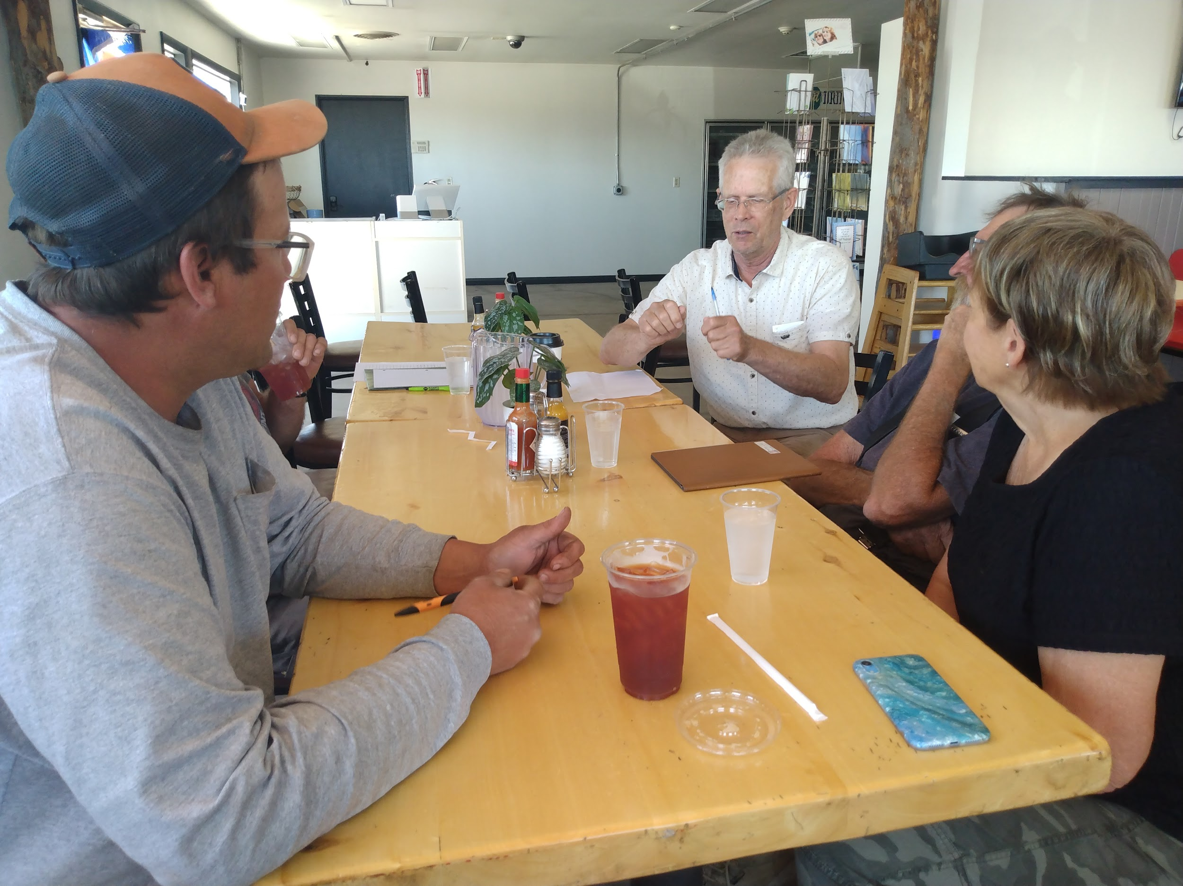
A peer learning circle of primarily potato growers at a local cafe, July 2025.
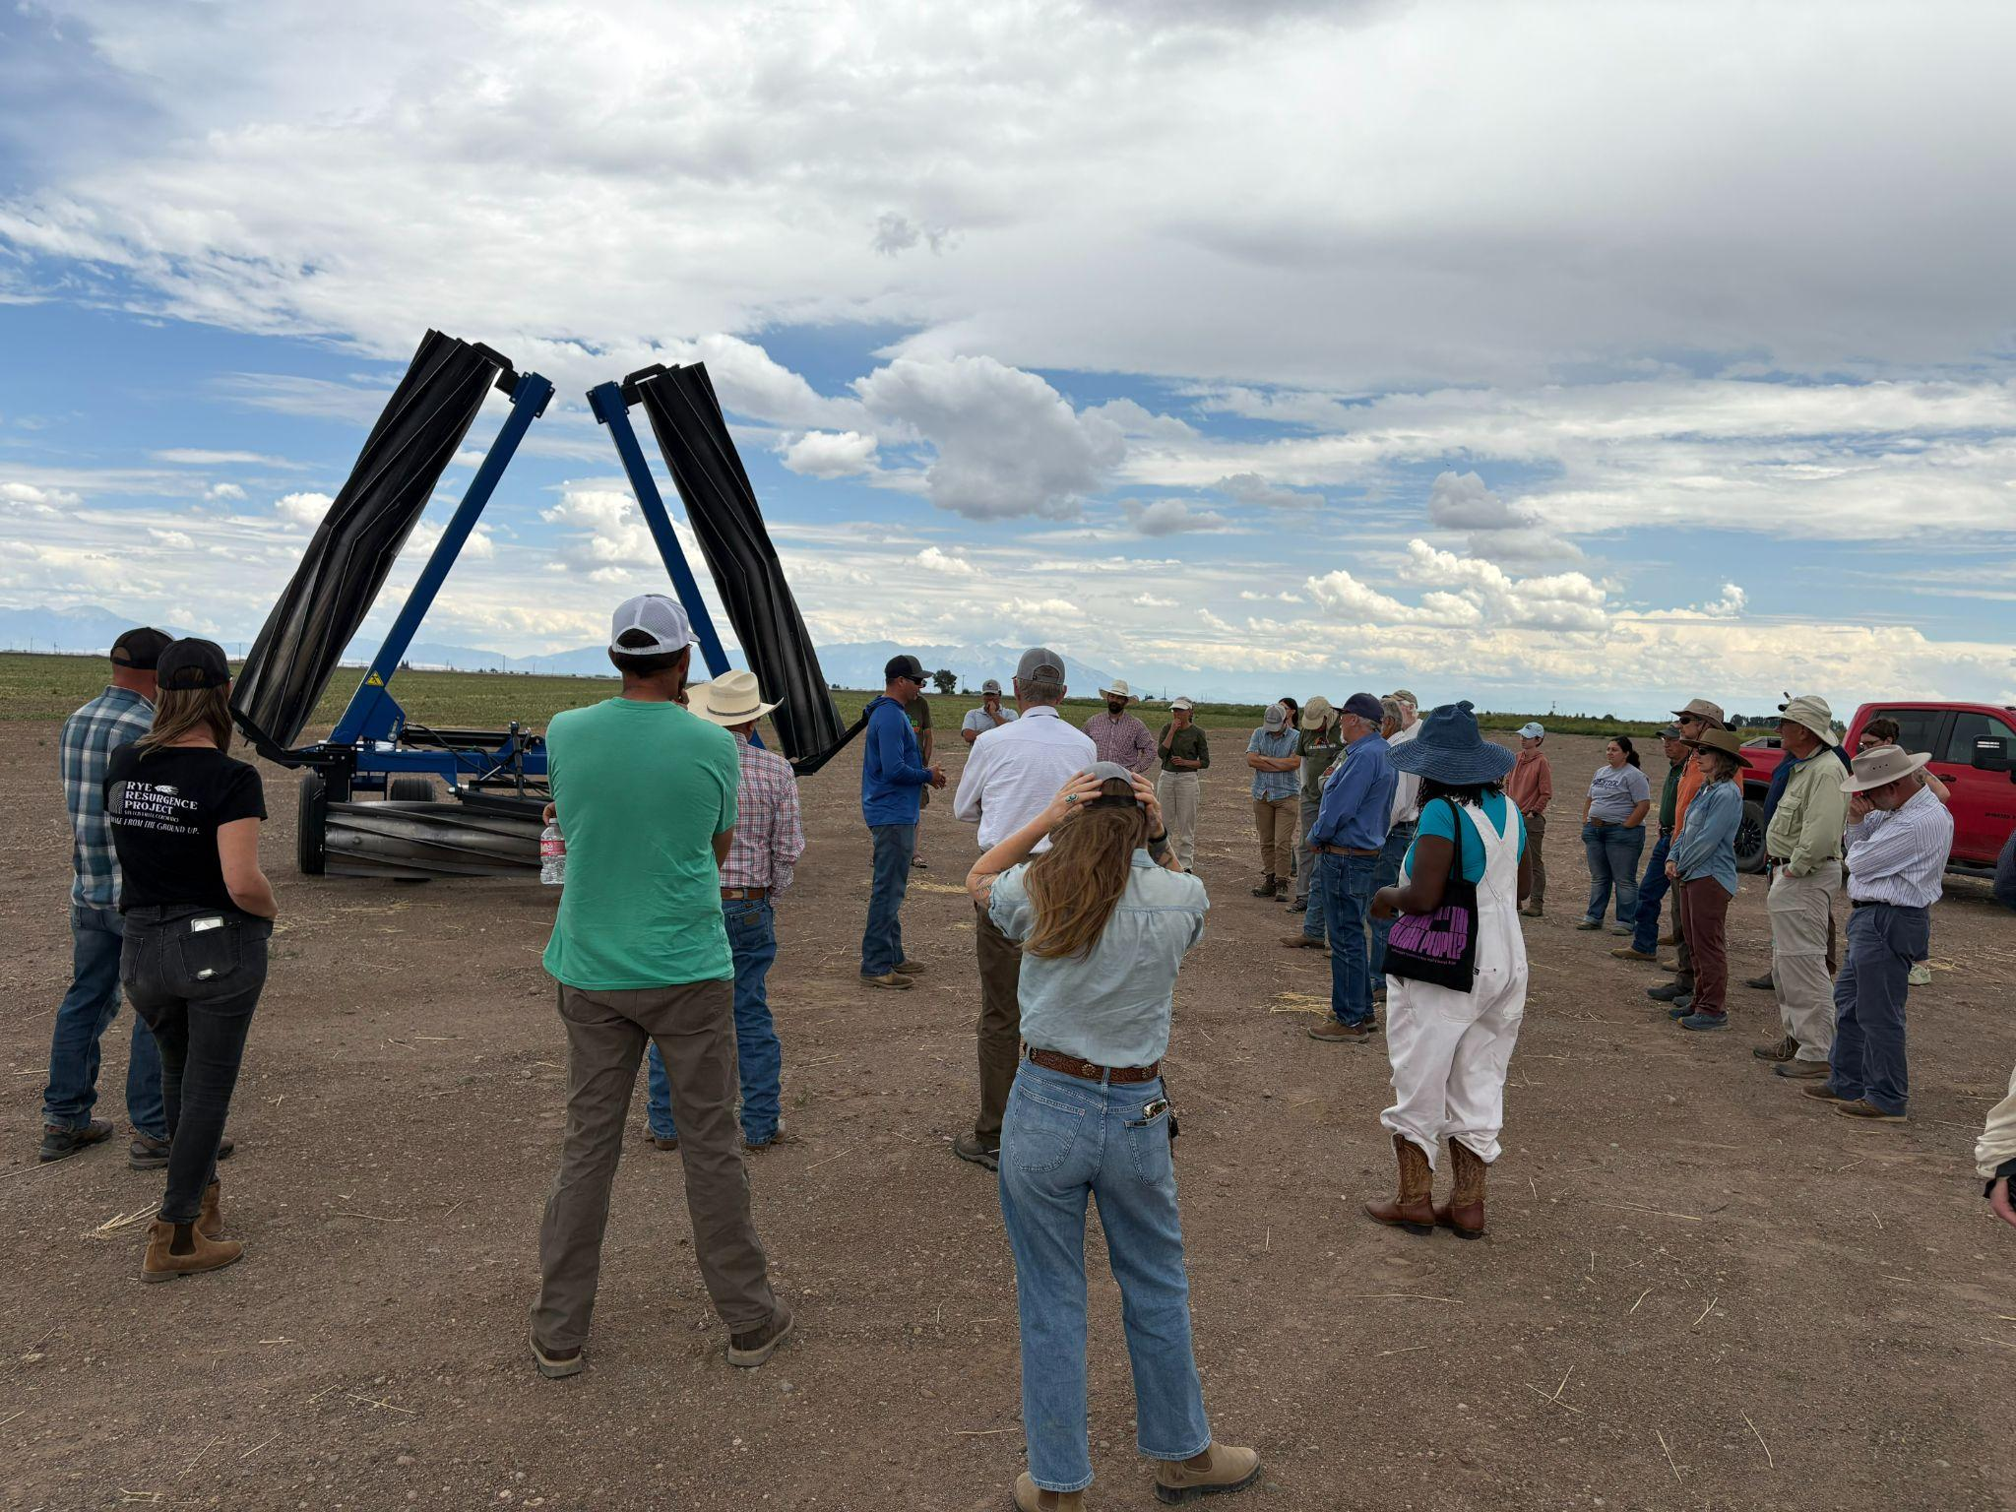
Field Day Stop 1: Jeff McCullough talks with the group about using crimped rye in a potato rotation, July 19, 2025.

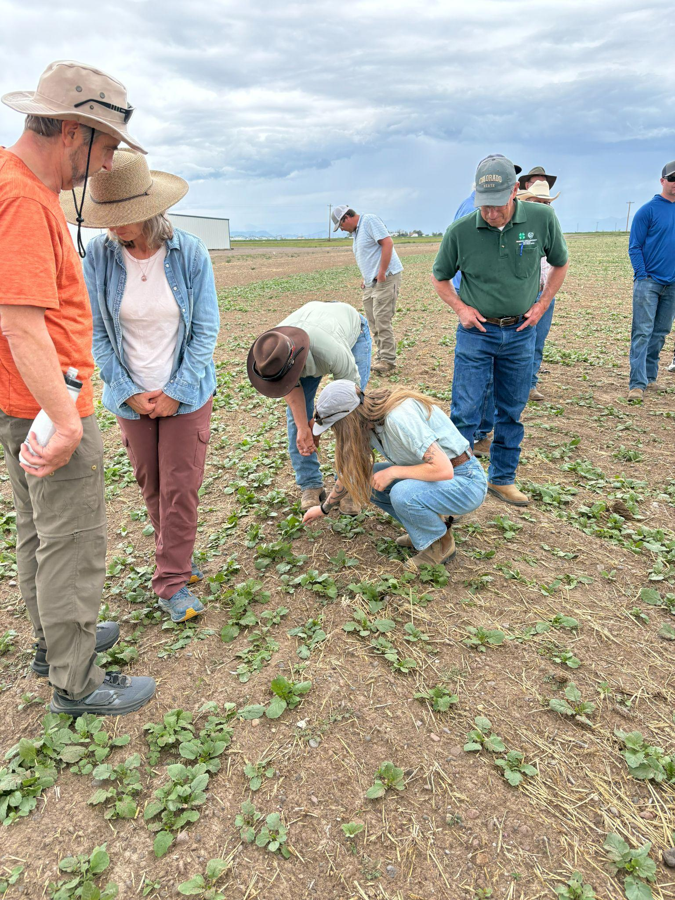
Field Day Stop 1: Participants look at the crimped rye/cover crop in Jeff’s field, July 19, 2025.

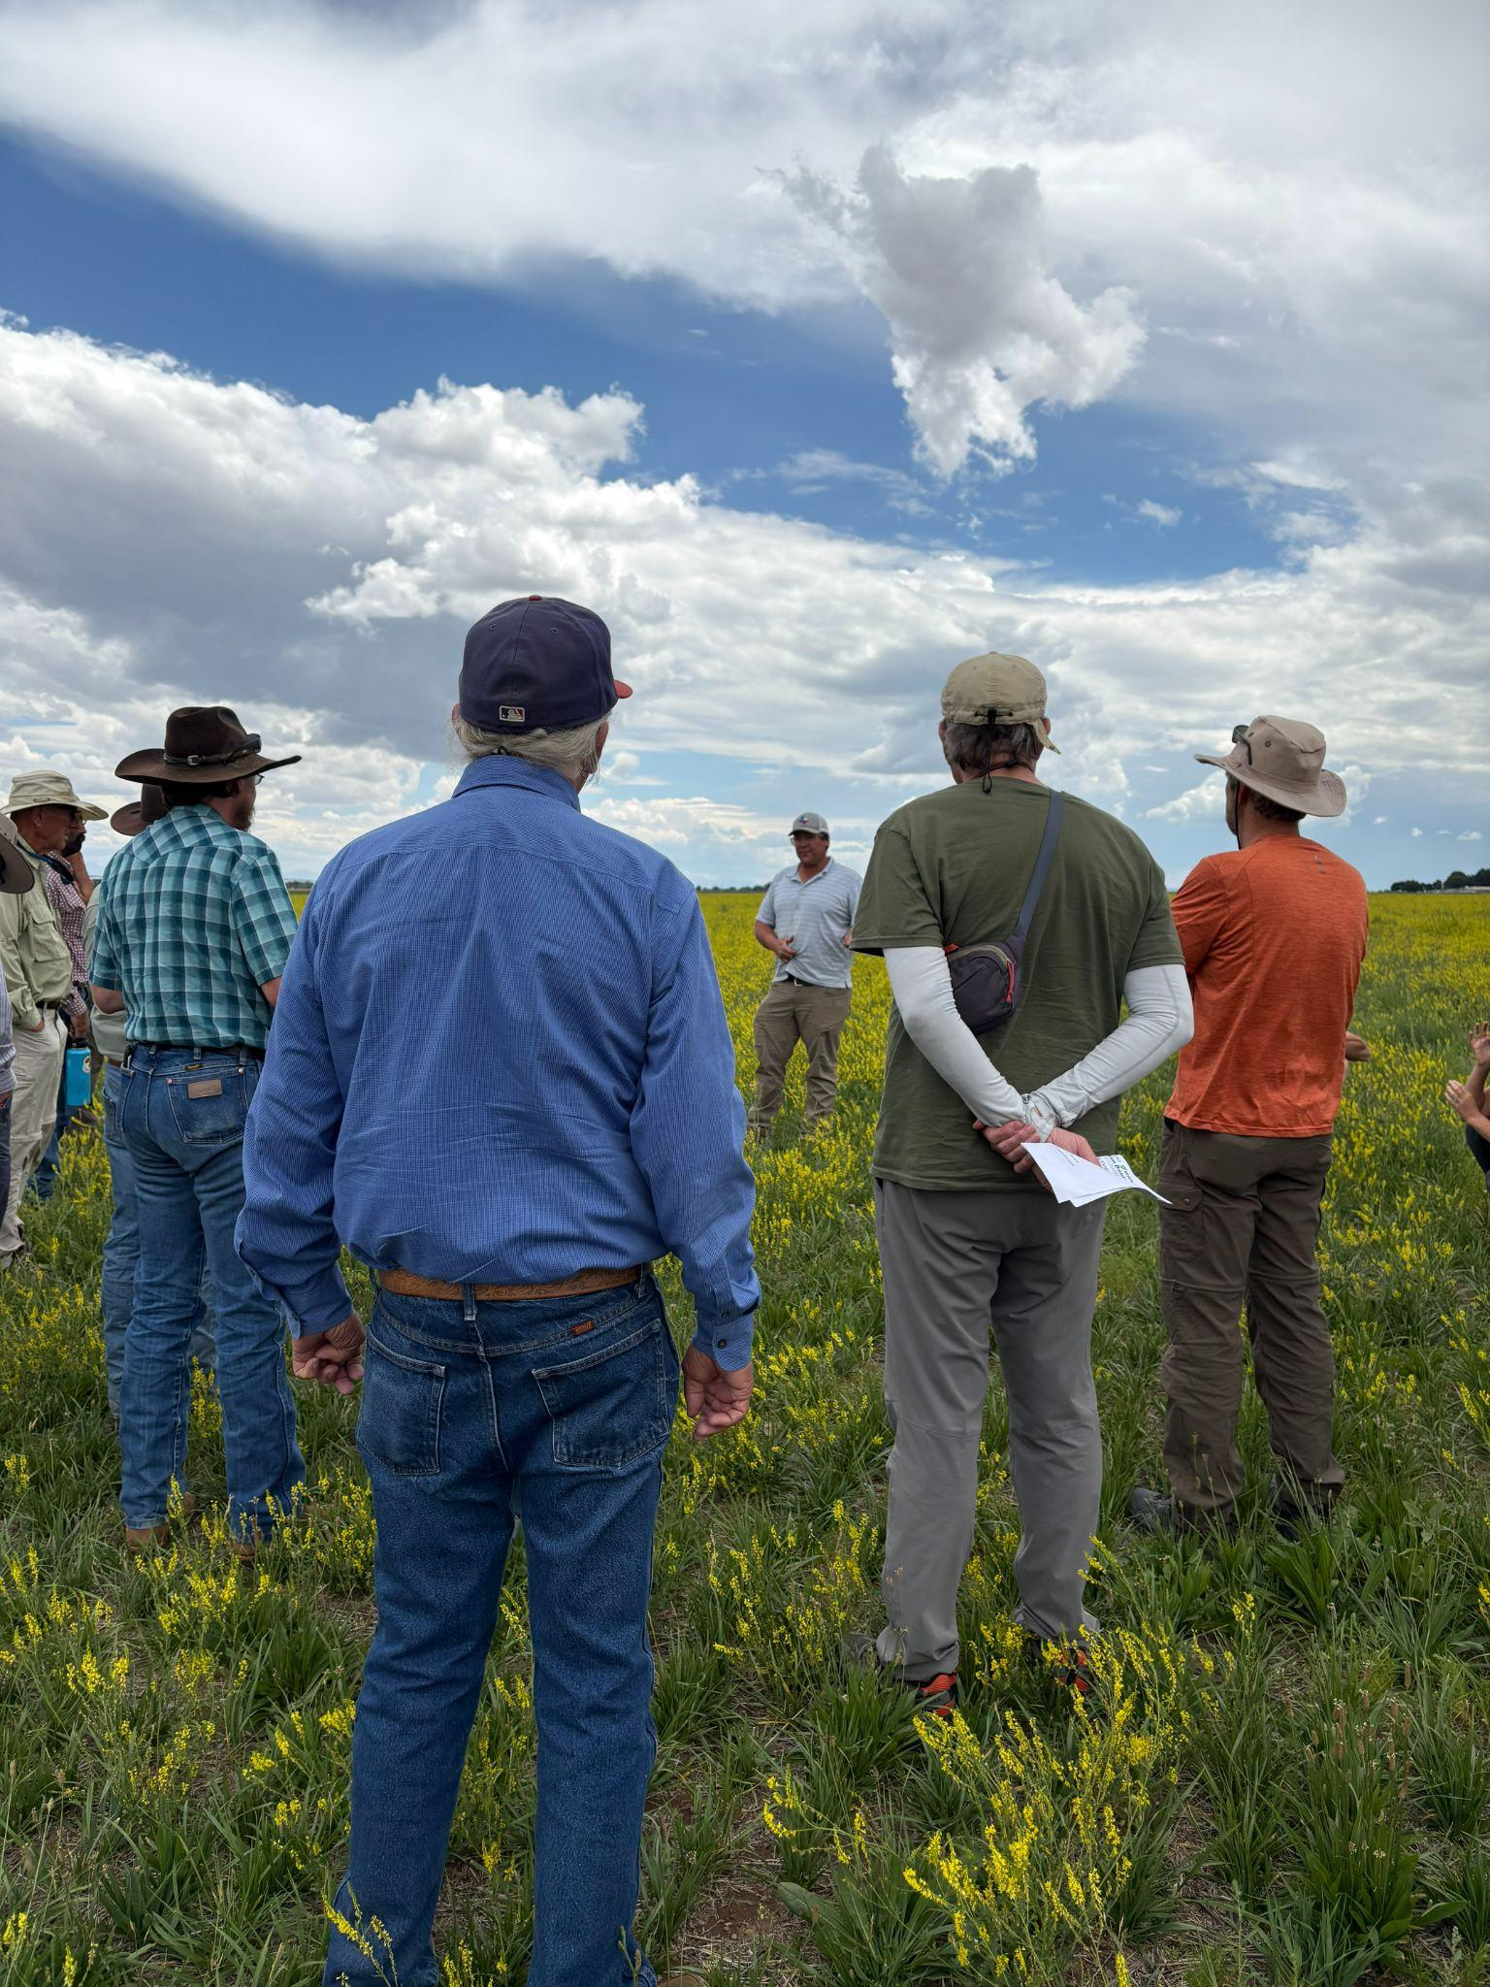
Field Day Stop 2: Lance Curtis shares with the group his cover crop practices, July 19, 2025.

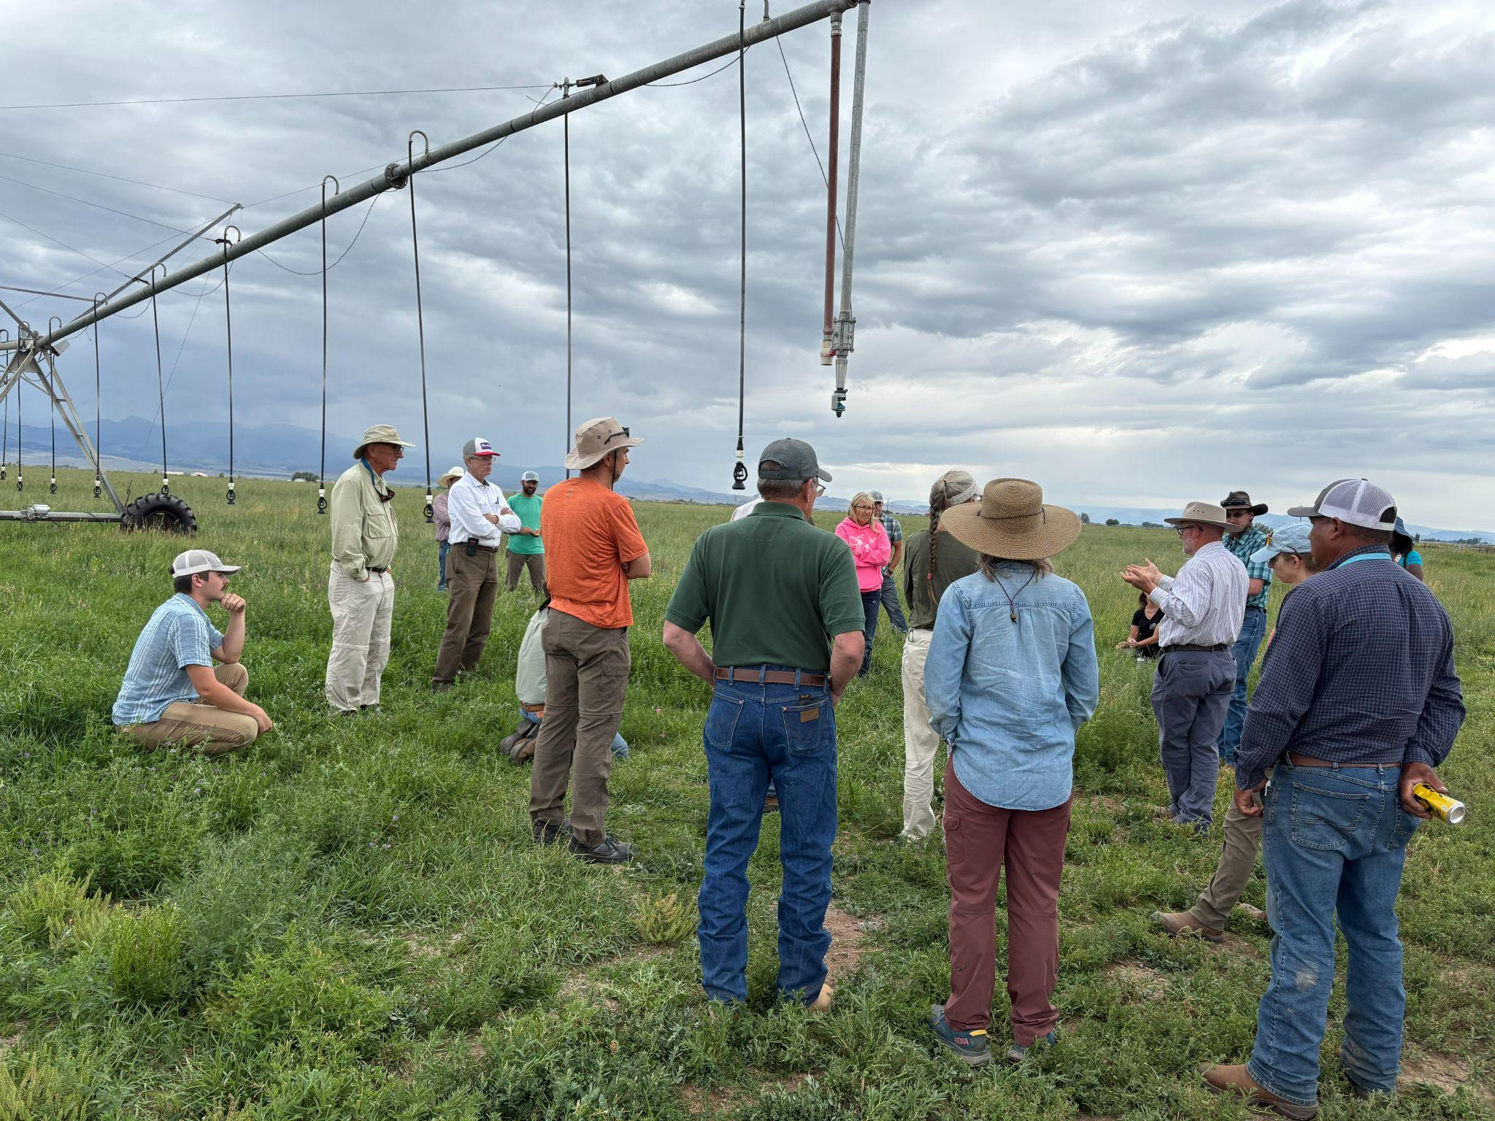
Field Day Stop 3: Pete and Leah Clark share about the conversion of their alfalfa pivot to less water intensive forages, July 19, 2025. 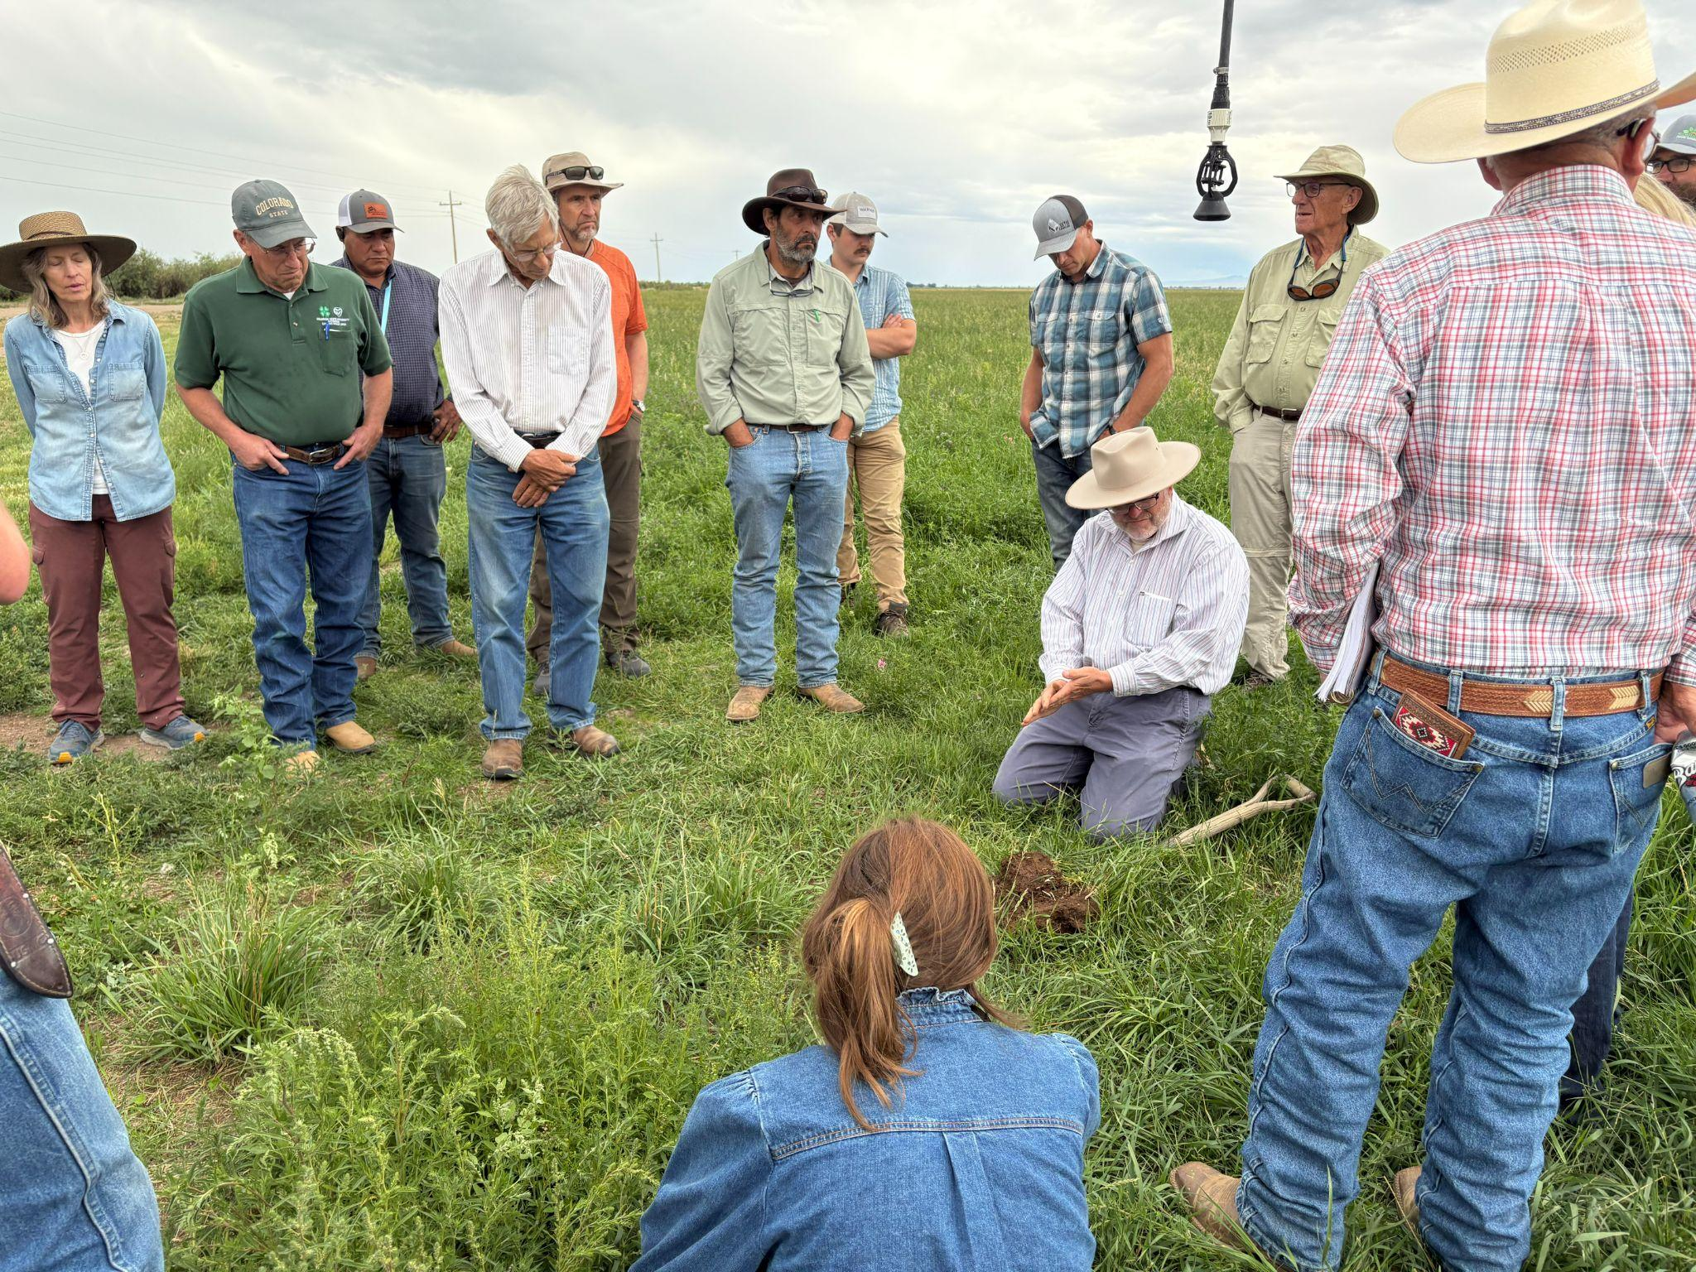
Field Day Stop 3: Patrick O’Neill shares with the group about the 5 Principles of Soil Health at work in this pivot, July 19, 2025.

Project Locations Map
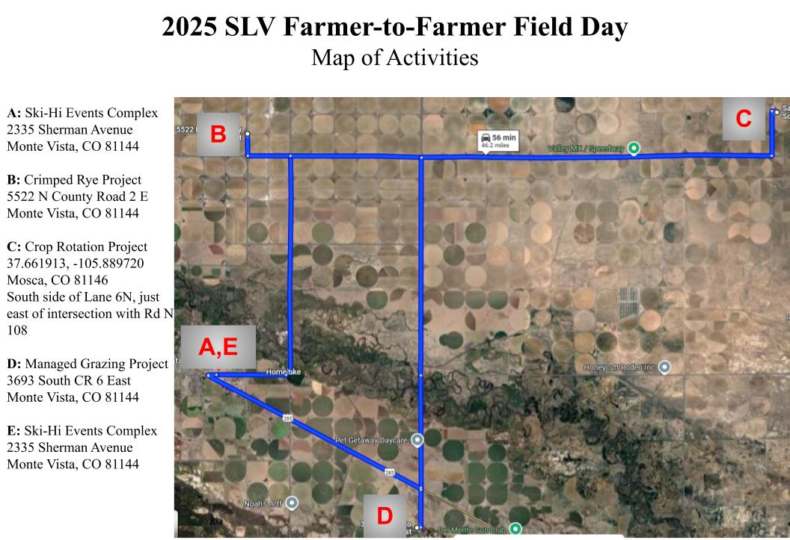
Map of farms and ranches visited for the Farmer-to-Farmer Field Day, July 19, 2025.

Publicity Article
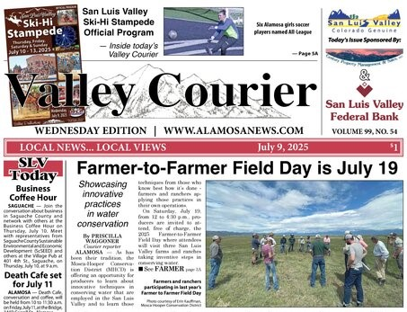
"Farmer-to-Farmer Field Day is July 19" by Priscilla Waggoner in the Valley Courier, 7/9/25

